LECTURE NOTES

ON

UTILIZATION OF ELECTRICAL

ENERGY

DETAILED CONTENTS

5.5 UTILIZATION OF ELECTRICAL ENERGY

RATIONALE
L T P
4 - -

This subject assumes importance in view of the fact that an electrical technician has to work in a wide spectrum of activities wherein he has to make selection from alternative schemes making technical and economical considerations; e.g. to plan and design an electrical layout using basic principles and handbooks, to select equipment, processes and components in different situations. The contents have been designed keeping the above objectives in view. Besides giving him basic knowledge in the topics concerned, attempts have been made to ensure that the knowledge acquired is applied in various fields as per his job requirements. To orient the subject matter in the proper direction, visits to industrial establishments are recommended in order to familiarize the students with the new developments in different areas

LEARNING OUTCOMES

After undergoing the subject, the student will be able to:

- Design lighting scheme for domestic, industrial and commercial installation
- Design and select a suitable heating arrangement for a particular job
- Handle and maintain electric welding equipment
- Handle and maintain electrolytic plant
- Find faults in electric circuits of refrigerators
- Suggest electric drives as per need
- Maintain electric traction lines and track

DETAILED CONTENTS

- Electric Heating (12 Periods)

Advantages of electrical heating
Heating methods:
Resistance heating – direct and indirect resistance heating, electric ovens, their temperature range, properties of resistance heating elements, domestic water heaters and other heating appliances, thermostat control circuit
Induction heating; principle of core type and coreless induction furnace, their construction and applications

Electric arc heating; direct and indirect arc heating, construction, working and applications of arc furnace
Dielectric heating, applications in various industrial fields
Infra-red heating and its applications (construction and working of two appliances)
Microwave heating and its applications (construction and working of two appliances)
1.2.7 Solar Heating

Calculation of resistance heating elements (simple problems)

- Electric Welding: (06 Periods)

Advantages of electric welding
Welding methods
2.2.1. Principles of resistance welding, types – spot, projection, seam and butt welding, welding equipment
2.2.2 Principle of arc production, electric arc welding, characteristics of arc; carbon arc, metal arc, hydrogen arc welding method and their applications. Power supply requirement. Advantages of using coated electrodes, comparison between AC and DC arc welding, welding control circuits, welding of aluminum and copper

- Electrolytic Processes: (12 Periods)

Need of electro-deposition
Laws of electrolysis, process of electro-deposition - clearing, operation, deposition of metals, polishing and buffing
Equipment and accessories for electroplating
Factors affecting electro-deposition
Principle of galvanizing and its applications
Principles of anodizing and its applications
Electroplating of non-conducting materials
Manufacture of chemicals by electrolytic process

- Electrical Circuits used in Refrigeration, Air Conditioning and Water Coolers:
(08 Periods)

Principle of air conditioning
Description of Electrical circuit used in
- Refrigerator,
- Air-conditioner, and
- Water cooler

- Electric Drives: (12 Periods)
Advantages of electric drives

Characteristics of different mechanical loads
Types of motors used as electric drive
General idea about the methods of power transfer by direct coupling by using devices like belt drive, gears, chain drives etc.
Examples of selection of motors for different types of domestic loads
Selection of drive for applications such as general workshop, textile mill, paper mill, steel mill, printing press, crane and lift etc. Application of flywheel.
Selection of motors for Domestic Appliances

- Electric Traction: (14 Periods)

Advantages of electric traction
Different systems of electric traction, DC and AC systems, diesel electric system, types of services – urban, sub-urban, and main line and their speed-time curves
Different accessories for track electrification; such as overhead catenary wire, conductor rail system, current collector-pentagraph
Factors affecting scheduled speed
6.5. Electrical block diagram of an electric locomotive with description of various equipment and accessories used.
Types of motors used for electric traction
Power supply arrangements
Starting and braking of electric locomotives
Introduction to EMU and metro railways
Train Lighting Scheme

Note: Students should be taken for visits to nearest electrified railway track and railway station to study the electric traction system.

INSTRUCTIONAL STRATEGY

It is desired to give ample practical examples in the class while teaching this subject. Teacher must supplement his/her classroom teaching with aids such as models, charts, and video films from time to time. This subject requires demonstrations and exposure to actual workplace/industry/field. For this purpose, the subject teacher should do advance planning for visits/studies related to each topic in consultation with HOD and Principal of the polytechnic/institution.

MEANS OF ASSESSMENT
- Assignments and quiz/class tests, mid-term and end-term written tests, model/prototype making
- Actual laboratory and practical work, model/prototype making, assembly and disassembly exercises and viva-voce
- Software installation, operation, development

RECOMMENDED BOOKS

- Art and Science of Utilization of Electrical Energy by H Partap, Dhanpat Rai & Sons, Delhi
- Utilization of Electrical Energy by JB Gupta, Kataria Publications, Ludhiana

- Utilization of Electrical Energy by Sahdev, Uneek Publication, Jalandhar

- A Text Book. of Electrical Power by Dr. SL Uppal, Khanna Publications, Delhi

- Modern Electric Traction by H Partap, Dhanpat Rai & Sons, Delhi

- Utilization of Electrical Energy by D.R. Arora, North Publication, Jalandhar

- Generation, Distribution and Utilization if Electrical Power by CL Wadhwa, Wiley Eastern Ltd., New Delhi
- e-books/e-tools/relevant software to be used as recommended by AICTE/HSBTE/NITTTR.

Websites for Reference:

http://swayam.gov.in

SUGGESTED DISTRIBUTION OF MARKS

Topic No. | Time Allotted  (Periods) | Marks Allocation  (%)
1 | 12 | 19
2 | 06 | 09
3 | 12 | 19
4 | 08 | 12
5 | 12 | 19
6 | 14 | 22
Total | 64 | 100

UNIT 1

Electric Heating

INTRODUCTION

Heat plays a major role in everyday life. All heating requirements in domestic purposes such as cooking, room heater, immersion water heaters, and electric toasters and also in industrial purposes such as welding, melting of metals, tempering, hardening, and drying can be met easily by electric heating, over the other forms of conventional heating. Heat and electricity are interchangeable. Heat also can be produced by passing the current through material to be heated. This is called electric heating; there are various methods of heating a material but electric heating is considered far superior compared to the heat produced by coal, oil, and natural gas.

2.2 Heating methods: 2.2.1 Resistance heating – direct and indirect resistance heating, electric ovens, their temperature range, properties of resistance heating elements, domestic water heaters and other heating appliances, thermostat control circuit 2.2.2 Induction heating; principle of core type and coreless induction furnace, their construction and applications 2.2.3 Electric arc heating; direct and indirect arc heating, construction, working and applications of arc furnace 2.2.4 Dielectric heating, applications in various industrial fields 2.2.5 Infra-red heating and its applications (construction and working of two appliances) 2.2.6 Microwave heating and its applications (construction and working of two appliances) 2.2.7 Solar Heating
2.3 Calculation of resistance heating elements (simple problems)

2.1 Advantages of electrical heating

The various advantages of electric heating over other the types of heating are:

(i) Economical

Electric heating equipment is cheaper; they do not require much skilled persons; therefore, maintenance cost is less.

(ii) Cleanliness

Since dust and ash are completely eliminated in the electric heating, it keeps surroundings cleanly.

(iii) Pollution free

As there are no flue gases in the electric heating, atmosphere around is pollution free; no need of providing space for their exit.

(iv) Ease of control

In this heating, temperature can be controlled and regulated accurately either manually or automatically.

(v) Uniform heating

With electric heating, the substance can be heated uniformly, throughout whether it may be conducting or non-conducting material.
(vi) High efficiency

In non-electric heating, only 40–60% of heat is utilized but in electric heating 75–100% of heat can be successfully utilized. So, overall efficiency of electric heating is very high.

(vii) Automatic protection

Protection against over current and over heating can be provided by using fast control devices.

(viii) Heating of non-conducting materials

The heat developed in the non-conducting materials such as wood and porcelain is possible only through the electric heating.

(ix) Better working conditions

No irritating noise is produced with electric heating and also radiating losses are low.

(x) Less floor area

Due to the compactness of electric furnace, floor area required is less.

(xi) High temperature

High temperature can be obtained by the electric heating except the ability of the material to withstand the heat.

(xii) Safety

The electric heating is quite safe.

MODES OF TRANSFER OF HEAT

The transmission of the heat energy from one body to another because of the temperature gradient takes place by any of the following methods:

- conduction,

- convection, or

- radiation.

Conduction

In this mode, the heat transfers from one part of substance to another part without the movement in the molecules of substance. The rate of the conduction of heat along the substance depends upon the temperature gradient.

The amount of heat passed through a cubic body with two parallel faces with thickness ‘t’ meters, having the cross-sectional area of ‘A’ square meters and the temperature of its two faces T₁°C and T₂°C, during ‘T’ hours is given by:
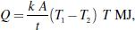

where k is the coefficient of the thermal conductivity for the material and it is measured in MJ/m³/°C/hr.

Ex: Refractory heating, the heating of insulating materials, etc.

Convection

In this mode, the heat transfer takes place from one part to another part of substance or fluid due to the actual motion of the molecules. The r te of conduction of heat depends mainly on the difference in the fluid density at different temperatures.

Ex: Immersion water heater.

The mount of heat absorbed by the water from heater through convection depends mainly upon the temperature of heating element and also depends partly on the position of the heater.

Heat dissipation is given by the following expression.

- = a (T₁ – T₂)^{b} W/m²,

where ‘a’ and ‘b’ are the constants whose values are depend upon the heating surface and T₁and T₂ are the temperatures of heating element and fluid in °C, respectively.

Radiation

In this mode, the heat transfers from source to the substance to be heated without heating the medium in between. It is dependent on surface.
Ex: Solar heaters.

The rate of heat dissipation through radiation is given by Stefan's Law.
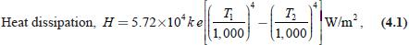

where T₁ is the temperature of the source in kelvin, T₂ is the temperature of the substance to be heated in kelvin, and k is the radiant efficiency:

- 1, for single element

- 0.5–0.8, for several elements e = emissivity = 1, for black body

- 0.9, for resistance heating element.

From Equation (4.1), the radiant heat is proportional to the difference of fourth power of the temperature, so it is very efficient heating at high te per ture.

ESSENTIAL REQUIREMENTS OF GOOD HEATING ELEMENT

The materials used for heating element should have the following properties:

- High-specific resis ance

Material should have high-specific resistance so that small length of wire may be required to provide given amount of heat.

- High-melting point

It should have high-melting point so that it can withstand for high temperature, a small increase in temperature will not destroy the element.

- Low temperature coefficient of resistance

From Equation (4.1), the radiant heat is proportional to fourth powers of the temperatures, it is very efficient heating at high temperature.

For accurate temperature control, the variation of resistance with the operating temperature should be very low. This can be obtained only if the material has low temperature coefficient of resistance

- Free from oxidation
The element material should not be oxidized when it is subjected to high temperatures; otherwise the formation of oxidized layers will shorten its life.

- High-mechanical strength

The material should have high-mechanical strength and should withstand for mechanical vibrations.

- Non-corrosive

The element should not corrode when exposed to atmosphere or any other chemical fumes.

- Economical

The cost of material should not be so high.

MATERIAL FOR HEATING ELEMENTS

The selection of a material for heating element is depending upon the service conditions such as maximum operating temperature and the amount of charge to be heated, but no single element will not satisfy all the requirements of the heating elements. The materials nor ally used as heating elements are either alloys of nickel–chromium, nickel–chr ium–iron, nickel– chromium–aluminum, or nickel–copper.

Nickel–chromium–iron alloy is cheaper when comp red to simple nickel–chromium alloy. The use of iron in the alloy reduces the cost of final product but, reduces the life of the alloy, as it gets oxidized soon. We have different types of alloys for heating elements. Table 4.1 gives the relevant properties of some of the commerci l heating elements.

Table : Properties of some heating elements
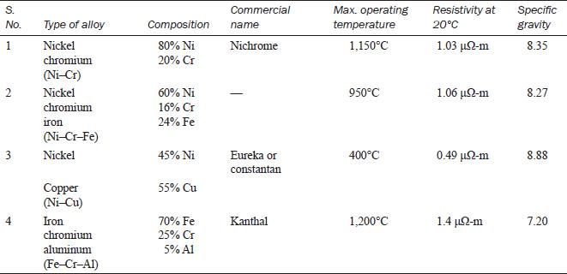

The properties of some commercial heating element materials commonly employed for low and medium temperatures up to 1,200°C are Ni–Cr and an alloy of Ni–Cr–Fe composition of these alloys are given in Table 4.1. For operating temperatures above 1,200°C, the heating elements are made up of silicon carbide, molebdenum, tungsten, and graphite. (Ni–Cu alloy is frequently used for heating elements operating at low temperatures. Its most important property is that it has virtually zero resistance and temperature coefficient.)

CAUSES OF FAILURE OF HEATING ELEMENTS

Heating element may fail due to any one of the following reasons.

- Formation of hot spots.

- Oxidation of the element and intermittency of operation.

- Embrittlement caused by gain growth.

- Contamination and corrosion.

Formation of hotspots

Hotspots are the points on the heating element gener lly t higher temperature than the main body. The main reasons of the formation of hotspot in the heating element are the high rate of the local oxidation causing reduction in the rea of cross-section of the element leading to the increase in the resistance at that spot. It gives rise to the damage of heating element due to the generation of more heat at spot. A other re son is the shielding of element by supports, etc., which reduces the local heat loss by radiation and hence the temperature of the shielded portion of the element will increase. So that the minimum number of supports should be used without producing the dis or ion of the element. The sagging and wrapping of the material arise due to the insufficient support for the element (or) selection of wrong fuse material may lead to the uneven spacing of sections thereby developing the hotspots on the element.

Oxidation and intermittency of operation

A continuous oxide layer is formed on the surface of the element at very high temperatures such layer is so strong that it prevents further oxidation of the inner metal of the element. If the element is used quite often, the oxide layer is subjected to thermal stresses; thus, the layer cracks and flakes off, thereby exposing fresh metal to oxidation. Thus, the local oxidation of the metal increases producing the hotspots.

Embrittlement causing grain growth

In general, most of the alloys containing iron tend to form large brittle grains at high temperatures. When cold, the elements are very brittle and liable to rupture easily on the slightest handling and jerks.

contamination and corrosion

The heating elements may be subjected to dry corrosion produced by their contamination with the gases of the controlled atmosphere prevailing in annealing furnaces.

2.3 Calculation of resistance heating elements (simple problems)

DESIGN OF HEATING ELEMENTS

By knowing the voltage and electrical energy input, the design of the heating element for an electric furnace is required to determine the size and length of the heating element. The wire employed may be circular or rectangular like a ribbon. The ribbon-type heating element permits the use of higher wattage per unit area compared to the circular-type element.

Circular-type heating element

Initially when the heating element is connected to the supply, the temperature goes on increasing and finally reaches high temperature.

Let V be the supply voltage of the system and R be the resistance of the ele ent, then electric
power input, 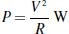.

If ρ is the resistivity of the element, l is the length, ‘ ’ is the area, and d is the diameter of the element, then:
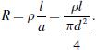

Therefore, power input,

By rearranging the above equation, we get:

where P is the electrical power input per phase (watt), V is the operating voltage per phase (volts), R is the resistance of the element (Ω), l is the length of the element (m), a is the area of cross-section (m²), d is the diameter of the element (m), and ρ is the specific resistance (Ω-m)

According to Stefan's law, heat dissipated per unit area is
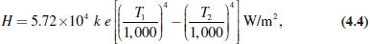

where T₁ is the absolute temperature of the element (K), T₂ is the abs lute te perature of the charge (K), e is the emissivity, and k is the radiant efficiency.

The surface area of the circular heating element:

S = πdl.
- Total heat dissipated = surface area × H

  - Hπ l.

Under thermal equilibri m,

Power input = heat dissipated

- = H × πdl.

Substituting P from Equation (4.2) in above equation:
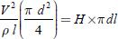

By solving Equations (4.3) and (4.4), the length and diameter of the wire can be determined.

Ribbon-type element

Let ‘w’ be the width and ‘t’ be the thickness of the ribbon-type heating element.

We know that, 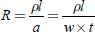 (for ribbon or rectangular element, a = w × t)
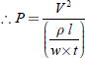

The surface area of the rectangular element (S) = 2 l × w.
  - Total heat dissipated = H × S

    - H × 2 lw.

- Under the thermal equilibrium, Electrical power input = heat dissipated

P = H × 2 lw

By solving Equations (4.7) and (4.8), the length and width of the heating element can be determined.

Example 4.1: A 4.5-kW, 200-V, and 1-φ resistance oven is to have nichrome wire heating elements. If the wire temperature is to be 1,000°C and that of the charge 500°C. Estimate the diameter and length of the wire. The resistivy of the nichrome alloy is 42.5 μΩ-m. Assume the radiating efficiency and the emissivity of the element as 1.0 and 0.9, respectively.

Solution:

Given data

Power input (P) = 4.5 kW

Supply voltage (V) = 200 V

Temperature of the source (T₁) = 1,000 + 273

- 1,273 K.

Temperature of the charge T₂ = 500 + 273

- 773 K.

According to the tefan's law,
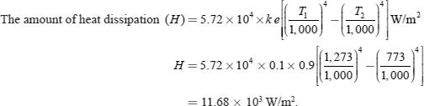

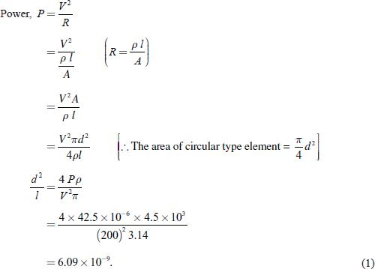

The heat dissipation is given by:
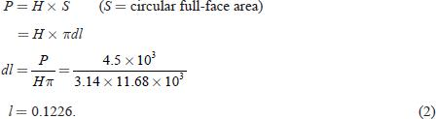

By solving Equations (1) and (2):

d³ = 0.7466

d = 0.907 mm.

Substitute the value of ‘d’ in Equation (2):

l = 135.14 m.

Example 4.2: A20-kW, 230-V, and single-phase resistance oven employs nickel—chrome strip 25-mm thick is used, for its heating elements. If the wire temperature is not to exceed 1,200°C and the temperature of the charge is to be 700°C. Calculate the width and length of the wire. Assume the radiating efficiency as 0.6 and emissivity as 0.9. Determine also the temperature of the wire when the charge is cold.

Solution:

Power supplied, P = 20 × 10³ W.

Let ‘w’ be the width in meters, t be the thickness in meters, and ‘l’ be the length also in meters. Then:
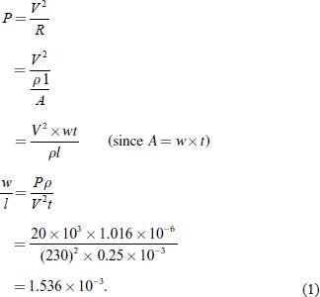

According to the Stefan's law of heat radiation:

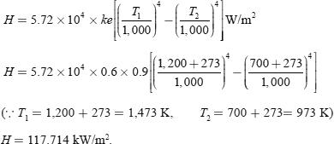

The total amount of the heat dissipation × the surface area of strip = power supplied P = H × S

- H × 2 lw (S = surface area of strip = 2lw)

From Equations (1) and (2):
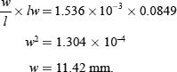

Substitute the value of ‘w’ in Equation (2) then:

l = 7.435 m.

When the charge is cold, it would be at normal temperature, say 25°C.

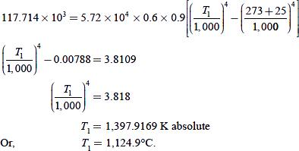

Example 4.3 Determine the diameter and length of the wire, if a 17-kW, 220-V, and 1-

φresistance oven employs nickel-chrome wire for its heating elements. The temperature is not exceeding to 1,100°C and the temperature of the charge is to be 500°C. Assume the radiating efficiency as 0.5 and the emissivity as 0.9, respectively.

Solution:

For a circular element:
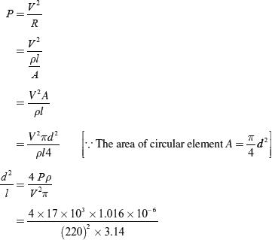

According to Stefan's law of heat dissipation:
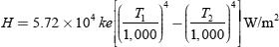
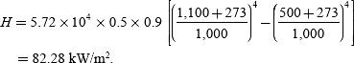

At steady temperature, crucial power input = heat output:
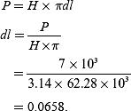

Solving Equations (1) and (2), we get:
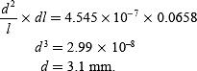

Substitute the value of ‘d' in Equation (2) gives:

l = 21.198 m.

2.2 METHODS OF ELECTRIC HEATING

Heat can be generated by passing the current through a resistance or induced currents. The initiation of an arc between two electrodes also develops heat. The bombardment by some heat energy particles such as α, γ, β, and x-rays or accelerating ion can produce heat on a surface.

Electric heating can be broadly classified as follows.

(i) Direct resistance heating

In this method, the electric current is made to pass through the charge (or) substance to be heated. This principle of heating is employed in electrode boiler.

(ii) Indirect resistance heating

In this method, the electric current is made to pass through a wire or high-resistance heating element, the heat so developed is transferred to charge from the heating element by convection or radiation. This method of heating is employed in immersion water heaters.
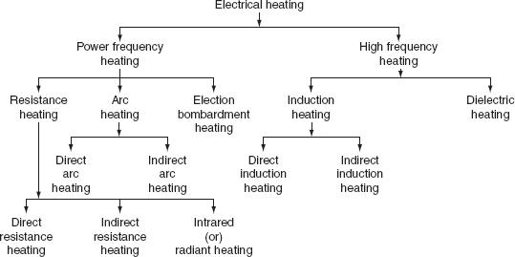

Fig. Classification of electrical heating

Infrared (or) radiant heating

In this method of heating, the heat energy is transferred from source (incandescent lamp) and focused upon the body to be heated up in the form of electromagnetic radiations. Normally, this method is used for drying clothes in the textile industry and to dry the wet paints on an object.

Direct arc heating

In this method, by striking the arc between the charge and the electrode or electrodes, the heat so developed is directly conducted and taken by the charge. The furnace operating on this principle is known as direct arc furnaces. The main application of this type of heating is production of steel.

Indirect arc heating

In this method, arc is established between the two electrodes, the heat so developed is transferred to the charge (or) substance by radiation. The furnaces operating on this principle are known as indirect arc furnaces. This method is generally used in the melting of non-ferrous metals.

Direct induction heating

In this method of heating, the currents are induced by electromagnetic action in the charge to be heated. These induced currents are used to melt the charge in induction furnace.

Indirect induction heating

In this method, eddy currents are induced in the heating element by electromagnetic action. Thus, the developed heat in the heating element is tr nsferred to the body (or) charge to be heated by radiation (or) convection. This principle of he ting is employed in induction furnaces used for the heat treatment of metals.

Dielectric heating

In this method of electric heating, the heat developed in a non-metallic material due to inter-atomic friction, known as ielectric loss. This principle of heating usually employed for preheating of plas ic performs, baking foundry cores, etc.

RESISTANCE HEATING

When the electric current is made to pass through a high-resistive body (or) substance, a power loss takes place in it, which results in the form of heat energy, i.e., resistance heating is passed upon the I²R effect. This method of heating has wide applications such as drying, baking of potteries, commercial and domestic cooking, and the heat treatment of metals such as annealing and hardening. In oven where wire resistances are employed for heating, temperature up to about 1,000°C can be obtained.

The resistance heating is further classified as:

- direct resistance heating,

- indirect resistance heating, and

- infrared (or) radiant heating.

Direct resistance heating

In this method, electrodes are immersed in a material or charge to be heated. The charge may be in the form of powder, pieces, or liquid. The electrodes are connected to AC or DC supply as shown in Fig. 4.1(a). In case of DC or 1-φ AC, two electrodes are immersed and three electrodes are immersed in the charge and connected to supply in case of availability of 3-φsupply. When metal pieces are to be heated, the powder of lightly resistive is sprinkled over the surface of the charge (or) pieces to avoid direct short circuit. The current flows through the charge and heat is produced in the charge itself. So, this method has high efficiency. As the current in this case is not variable, so that automatic temperature control is not possible. This method of heating is employed in salt bath furnace and electrode boiler for heating water.
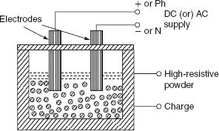

Fig. (a) Direct resis ance heating

(i) Salt bath furnace

This type of furnace consists of a bath and containing some salt such as molten sodium chloride and two electrodes immersed in it.

Such salt have a fusing point of about 1,000–1,500°C depending upon the type of salt used. When the current is passed between the electrodes immersed in the salt, heat is developed and the temperature of the salt bath may be increased. Such an arrangement is known as a salt bath furnace.

In this bath, the material or job to be heated is dipped. The electrodes should be carefully immersed in the bath in such a way that the current flows through the salt and not through the job being heated. As DC will cause electrolysis so, low-voltage AC up to 20 V and current up to 3,000 A is adopted depending upon the type of furnaces.

The resistance of the salt decreases with increase in the temperature of the salt, therefore, in order to maintain the constant power input, the voltage can be controlled by providing a tap changing transformer. The control of power input is also affected by varying the depth of immersion and the distance between the electrodes.

(ii) Electrode boiler

It is used to heat the water by immersing three electrodes in a tank as shown in Fig. 4.2. This is based on the principle that when the electric current passed through the water produces heat due to the resistance offered by it. For DC supply, it results in a lot of evolution of H₂ at negative electrode and O₂ at positive electrode. Whereas AC supply hardly results in any evolution of gas, but heats the water. Electrode boiler tank is earthed solidly and connected to the ground. A circuit breaker is usually incorporated to make and break all poles simultaneously and an over current protective device is provided in each conductor feeding an electrode.
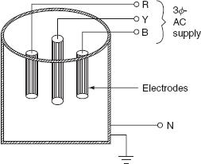

Fig. 4.2 Electrode boiler

Indirect resistance heating

In the indirect resistance heating method, high current is passed through the heating element. In case of industrial heating, some times the heating element is placed in a cylinder which is surrounded by the charge placed in a jacket is known as heating chamber is shown inFig. 4.3. The heat is proportional to power loss produced in the heating element is delivered to the charge by one or more of the modes of the transfer of heat viz. conduction, convection, and radiation. This arrangement provides uniform temperature and automatic temperature control. Generally, this method of heating is used in immersion water heaters, room heaters, and the resistance ovens used in domestic and commercial cooling and salt bath furnace.

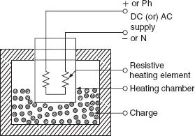

Fig. 4.3 Indirect resistance heating

Resistance ovens

According to the operating temperatures, the resistance furnaces may be classified into various types. Low-temperature heating chamber with the provision for ventilation is called as oven. For drying varnish coating, the hardening of synthetic materials, and m ercialand domestic heating, etc., the resistance ovens are employed. The operating temperature of medium temperature furnaces is between 300°C and 1,050°C. These re employed for the melting of non-ferrous metals, stove (annealing), etc. Furnaces oper ting t temperature between 1,050°C and 1,350°C are known as high-temperature furn ces. These furnaces are employed for hardening applications. A simple resistance oven is shown in Fig. 4.4.
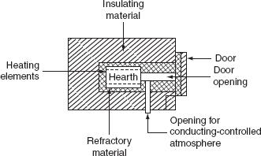

Fig. 4.4 Resistance oven

Resistance oven consists of a heating chamber in which heating elements are placed as shown in the Fig. 4.4. The inner surface of the heating chamber is made to suit the character of the

charge and the type of furnace or oven. The type of insulation used for heating chamber is determined by the maximum temperature of the heating chamber.

Efficiency and losses of resistance ovens

The heat produced in the heating elements, not only raises the temperature of the charge to desired value, but also used to overcome the losses occurring due to:

- Heat used in raising the temperature of oven (or) furnace.

- Heat used in raising the temperature of containers (or) carriers,

- Heat conducted through the walls.

- Heat loss due to the opening of oven door.

- The heat required to raise the temperature of oven to desired value can be calculated by knowing the mass of refractory material (M), its specific heat (S), and raise of temperature (∆T) and is given by:

H_{oven} = MS∆TJ.

In case the oven is continuously used, this loss becomes negligible.

- Heat used in rising the temperature of containers (or) carriers can be calculated exactly the same way as for oven (or) furnaces.

3. Heat loss conducted through the walls of the container c n be l ulated by knowing the area of the container (A) in square meters, the thickness of the w lls (t) in meters, the inside and out side temperatures of the container T₁ and T₂ in °C, respectively, nd the thermal conductivity of the container
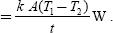

walls ‘k’ in m³/°C/hr and is given b : He t loss by conduction

Actually, there is no specific formula for the determination of loss occurring due to the opening of door for the periodic inspection of the charge so that this loss may be approximately taken as 0.58–1.15 MJ/m² of he door area, if the door is opened for a period of 20–30 sec.

The efficiency of the oven is defined as the ratio of the heat required to raise the temperature of the charge to the desired value to the heat required to raise the charge and losses.

The efficiency of the oven:

The efficiency of the resistance oven lies in between 60% and 80%.
Infrared or radiant heating

In this method of heating, the heat transfer takes place from the source to the body to be heated through radiation, for low and medium temperature applications. Whereas in resistance ovens, the heat transfers to the charge partly by convection and partly by radiation. In the radiant heating, the heating element consists of tungsten filament lamps together with reflector and to direct all the heat on the charge. Tungsten filament lamps are operating at 2,300°C instead of 3,000°C to give greater portion of infrared radiation and a longer life. The radiant heating is mainly used for drying enamel or painted surfaces. The high concentration of the radiant energy enables the heat to penetrate the coating of paint or enamel to a depth sufficient to dry it out without wasting energy in the body of the workpiece.

The main advantage of the radiant heating is that the heat absorption remains approximately constant whatever the charge temperature, whereas with the ordinary oven the heat absorption falls off very considerably as the temperature of the charge raises. The lamp ratings used are usually between 250 and 1,000 W and are operating at voltage of 115 V in order to ensure a robust filament.

TEMPERATURE CONTROL OF RESISTANCE HEATING

To control the temperature of a resistance heating at certain sele ted p ints in a furnace or oven, as per certain limits, such control may be required in order to hold the temperature constant or to vary it in accordance with a pre-determined cycle and it c n be carried out by hand or automatically.

In resistance furnaces, the heat developed depends upon I² R t (or) t. Therefore, the temperature of the f rnaces can be controlled either by:

- Changing the resistance of elements.

- Changing the applied voltage to the elements (or) current passing through the elements.

- Changing the ratio of the on-and-off times of the supply.

Voltage across the furnace can be controlled by changing the transformer tapings. Auto transformer or induction regulator can also be used for variable voltage supply. In addition to the above, voltage can be controlled by using a series resistance so that some voltage dropped across this series resistor. But this method is not economical as the power is continuously wasted in controlling the resistance. Hence, this method is limited to small furnaces. An on-off switch can be employed to control the temperature. The time for which the oven is connected to the supply and the time for which it is disconnected from supply will determine the temperature.

Temperature can be controlled by providing various combinations of groups of resistances used in the furnace and is given as follows:

(i) Variable number of elements

If ‘R’ be the resistance of one element and ‘n’ be the number of elements are connected in parallel, so that the equivalent resistance is R/n.

Heat developed in the furnace is:
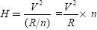

i.e., if the number of elements connected in parallel increases, the heat developed in the furnace also increased. This method does not provide uniform heating unless elements not in use are well distributed.

(ii) Series parallel (or) star delta arrangement of ele ents

If the available supply is single phase, the heating elements an be nnected in series for the low temperatures and connected in parallel for the high temperature by means of a series— parallel switch.

In case, if the available supply is three ph se, the heating elements can be connected in star for the low temperature and in delta for the high temperatures by using star—delta switch.

Example 4.5: Six resistances, each of 60 ohms, are used in a resistance; how much power is drawn for the following connections.

- Supply is 400 V, AC, and single phase and the connections are:

  - Three groups in parallel, each of two resistance units in series.

  - Six groups are in parallel, each of one resistance unit.

    - With the same three-phase supply, they are connected in delta fashion.

- Two resistance units in parallel in each branch.

  - Two resistance units in series in each branch.

    - Supply is 400 V and three-phase while the connection is a star combination of:

- Two resistance elements in series in each phase.

- Two resistance elements in parallel in each phase.

- If the supply is a 25% tapping with an auto transformer, calculate the output of the oven.

Solution:

1.

  - The power consumption of the two resistances in series is:

The power consumed by the three units in parallel is P = 3 × 1,333.33 = 4,000 W.

- The power consumed by each resistor is:
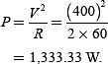
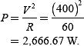

The power consumed by the six resistors in p rallel is:

P = 6 × 2,666.67

      - 16,000 W.

  - Since in delta fashion, line voltage = phase voltage = 400 V:

    - The power consumed by the each branch:

The power consumed by the three units is: P = 3 × 5,333.34

      - 16,000 W.

- The power consumed by the each unit, when they are commuted in series is:
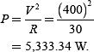
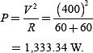

The power consumed by the three units is:

P = 4,000 W.

  - For the star connection,

- The power consumed by the two resistors in series is 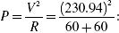 p = 444.44 W.

The power consumed by the three units is: P = 1,333.33 W.

- The power consumed by the two resistors in parallel is:
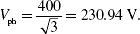
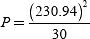

The power consumed by the three units in series is:

P = 3 × 1,777.77

  - 5,333.32 W.

- The power is proportional to the square of the voltage. Hence, the voltage is 25%. So that, the power
loss will be th of the values obtained as above.

ARC HEATING

If the high voltage is applied across an air gap, the air in the gap gets ionized under the influence of electrostatic forces and becomes conducting medium, current flows in the form of a continuous spark, known as arc. A very high voltage is required to establish an arc but very small voltage is sufficient to maintain it, across the air gap. The high voltage required for striking an arc can be obtained by using a step-up transformer fed from a variable AC supply.

Another method of striking the arc by using low voltage is by short circuiting the two electrodes momentarily and with drawing them back. Electrodes made up of carbon or graphite and are used in the arc furnaces when the temperature obtained is in the range of 3,000–3,500°C.

Electrodes used in the arc furnaces

Normally used electrodes in the arc furnaces are carbon electrodes, graphite electrodes, and self-baking electrodes. Usually the carbon and graphite electrodes are used and they can be selected based on their electrical conductivity insolubility, chemical inertness, mechanical strength, resistance to thermal shock, etc. The size of these electrodes may be 18–27 cm in diameter. The carbon electrodes are used with small furnaces for manufacturing of ferro-alloys, aluminum phosphorous, etc. The self-baking electrodes are employed in the electrochemical furnaces and in the electrolytic production of aluminum.

The salient features of carbon and graphite electrodes are:

- Resistivity: The graphite electrodes have low-specific resistance than the carbon electrodes, so the graphite required half in size for the same current resulting in easy replacement.

- Oxidation: Graphite begins to oxides at 600°C where as carbon at 400°C.

- Electrode consumption: For steel-melting furnaces, the consumption of the carbon electrodes is about 4.5 kg of electrodes per tonne of steel and 2.3–to 6.8 kg electrodes per tonne of steel for the graphite electrodes.

- Cost: The graphite electrodes cost about twice as much per kg as the carbon electrodes. The choice of electrodes depends chiefly on the question of the total cost. In general, if the processes requiring large quantities of electrode, carbon is used but for other processes, the choice depends on local conditions.

Types of arc furnaces

There are two types of arc furnaces and they are:

- direct arc furnace and

- indirect arc furnace.

(i) Direct Arc furnace

When supply is given to the electrodes, two arcs are established and current passes through the charge, as shown in Fig. 4.5. As the arc is in direct contact with the charge and heat is also produced by current flowing through the charge itself, it is known as direct arc furnace.

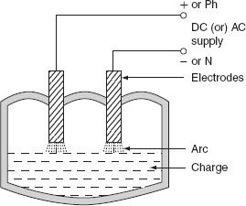

Fig. Direct arc furnace

If the available supply is DC or 1-φ, AC, two electrodes are sufficient, if the supply is 3-φ, AC, three electrodes are placed at three vertices of an equilateral triangle. The most important feature of the direct arc furnace is that the current flows through the charge, the stirring action is inherent due to the electromagnetic force setup by the current, such furnace is used for manufacturing alloy steel and gives purer product.

It is very simple and easy to control the composition of the final product during refining process operating the power factor of arc furnace is 0.8 lagging. For 1-ton furnace, the power required is about 200 kW and the energy consumed is 1.0 MWh/ton.

(ii) Indirect arc furnace

In indirect arc furnace, the arc strikes between two electrodes by bringing o entarily in contact and then with drawing them heat so developed, due to the striking f arc across air gap is transferred to charge is purely by radiation. A simple indire t arc furnace is shown inFig. 4.6.
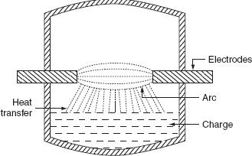

Fig. 4.6 Indirect arc furnace

These furnaces are usually l-φ and hence their size is limited by the amount of one-phase load which can be taken from one point. There is no inherent stirring action provided in this furnace, as current does not flow through the charge and the furnace must be rocked mechanically. The electrodes are projected through this chamber at each end along the horizontal axis. This furnaceis also sometimes called as rocking arc furnace. The charge in this furnace is heated not only by radiation from the arc between electrode tips but also by conduction from the heated refractory during rocking action; so, the efficiency of such furnace is high. The arc is produced by bringing electrodes into solid contact and then withdrawing them; power input to the furnace is regulated by adjusting the arc length by moving the electrodes. Even though it can be used in iron foundries where small quantities of iron are required frequently, the main application of this furnace is the melting of non-ferrous metals.

Example 4.6: Calculate the time taken to melt 5 ton of steel in three-phase arc furnace having the following data.

Current = 8,000 A |  |  | Resistance = 0.003 Ω
 | Arc voltage = 50 V |  |  | Reactance = 0.005 Ω
Latent heat = 8.89 kcal/kg |  |  | Specific heat = 0.12
 | Initial temperature = 18°C |  |  | Melting point = 1,370°C

The overall efficiency is 50%. Find also the power factor and the electrical efficiency of the furnace.

Solution:

The equivalent circuit of the furnace is shown in Fig. P.4.1.

Arc resistance per phase 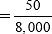

Fig. P.4.1 Equivalent circuit of arc furnace
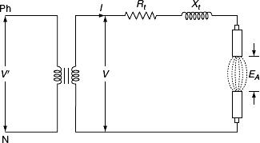

R_{A} = 0.00625 Ω.

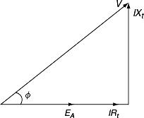
Drop due to the resistance of transformer, I R_{t} = 8,000 × 0.003 = 24 V and drop due to the reactance, I X_{t} = 8,000 × 0.005 = 40 V.

From the phasor diagram (Fig. P.4.2):

Fig. P.4.2 Phasor diagram

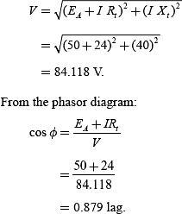

The amount of heat required per kg of steel:

- Specific heat × (t₂ - t₁) + latent heat

- 0.12 × (1,370-18) + 8.89

- 171.13 kcal.
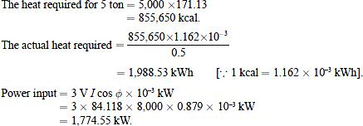
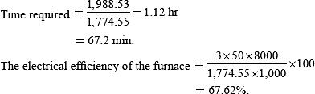

Example 4.7: A 100-kW Ajax Wyatt furnace works at a secondary voltage of 12 V at power factor 0.6 when fully charged. If the reactance presented by the charge remains constant but the resistance varies invert as the charge depth in the furnace; calculate the charge depth that produces maximum heating effect when the furnace is fully charged.

Solution:

Secondary power, P = V₂I₂ cos φ
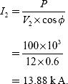

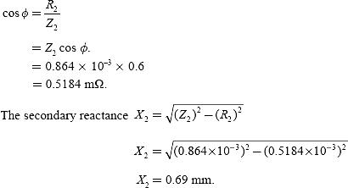

When the crucible is fully charged, then the secondary impedance is:
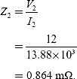

From the impedance triangle:
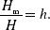
Let ‘H’ be the height of the crucible when the crucible is full of charge and ‘H_{m}’ be the height of the charge at which maximum heating effect is possible.

Given that the height of the charge is i versely proportional to the resistance. Let ‘R_{m}’ be the maximum resistance at which maximum he ting effect will be possible.
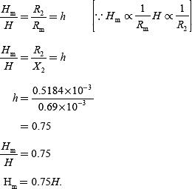
At R_{m} = X₂, the heat produced will be maximum.

HIGH-FREQUENCY HEATING

The main difference between the power-frequency and the high-frequency heating is that in the conventional methods, the heat is transferred either by conduction convection or by radiation, but in the high-frequency heating methods, the electromagnetic energy converted into the heat energy in side the material.

The high-frequency heating can be applied to two types of materials. The heating of the conducting materials, such as ferro-magnetic and non-ferro-magnetic, is known as induction heating. The process of heating of the insulating materials is known as dielectric heating. The heat transfer by the conventional method is very low of the order of 0.5–20 W/sq. cm. And, the heat transfer rate by the high-frequency heating either by induction or by dielectric heating is as much as 10,000 W/sq. cm. Thus, the high-frequency heating is most importance for tremendous speed of production.

INDUCTION HEATING

The induction heating process makes use of the currents induced by the electro agnetic action in the material to be heated. To develop sufficient amount of heat, the resistance of the material

must be low , which is possible only with the metals, and the voltage must be higher, which can be obtained by employing higher flux nd higher frequency. Therefore, the magnetic materials can be heated than non- gnetic aterials due to their high permeability.

In order to analyze the factors affecti g induction heating, let us consider a circular disc to be heated carrying a current of ‘I’ amps at a frequency ‘f’ Hz. As shown in Fig. 4.9.
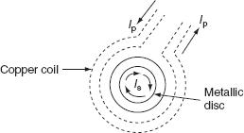

Fig. 4.9 Induction heating

Heat developed in the disc is depending upon the following factors.

- Primary coil current.

- The number of the turns of the coil. o Supply frequency.

o The magnetic coupling between the coil and the disc. o The high electrical resistivity of the disc.

If the charge to be heated is non-magnetic, then the heat developed is due to eddy current loss, whereas if it is magnetic material, there will be hysteresis loss in addition to eddy current loss. Both hysteresis and eddy current loss are depended upon frequency, but at high-frequency hysteresis, loss is very small as compared to eddy currents.

The depth of penetration of induced currents into the disc is given by:
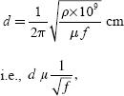

where ρ is the specific resistance in Ω-cm, f is the frequency in Hz, and μ is the permeability of the charge.

There are basically two types of i duction furnaces and they are:

- Core type or low-freq ency induction furnace.

- Coreless type or high-frequency induction furnace.

Core type furnace

The operating principle of the core type furnace is the electromagnetic induction. This furnace is operating just like a transformer. It is further classified as:

- Direct core type.

- Vertical core type.

- Indirect core type.

(i) Direct core type induction furnace

The core type furnace is essentially a transformer in which the charge to be heated forms single-turn secondary circuit and is magnetically coupled to the primary by an iron core as shown in Fig. 4.10.
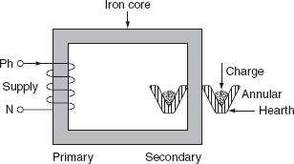

Fig. 4.10 Direct core type furnace

The furnace consists of a circular he rth in the form of a trough, which contains the charge to be melted in the form of an annular ri g. This type of furnace has the following characteristics:

- This metal ring is q ite large in diameter and is magnetically interlinked with primary winding, which is energized from an AC so rce. The magnetic coupling between primary and secondary is very weak; it results in high leakage reactance and low pf. To overcome the increase in leakage reactance, the furnace should be operated at low frequency of the order of 10 Hz.

- When there is no molten metal in the hearth, the secondary becomes open circuited thereby cutting of secondary current. Hence, to start the furnace, the molten metal has to be taken in the hearth to keep the secondary as short circuit.

- Furnace is operating at normal frequency, which causes turbulence and severe stirring action in the

molten metal to avoid this difficulty, it is also necessary to operate the furnace at low frequency.

- In order to obtain low-frequency supply, separate motor-generator set (or) frequency changer is to be provided, which involves the extra cost.

- The crucible used for the charge is of odd shape and inconvenient from the metallurgical viewpoint.

o If current density exceeds about 500 A/cm², it will produce high-electromagnetic forces in the molten metal and hence adjacent molecules repel each other, as they are in the same direction. The repulsion may cause the interruption of secondary circuit (formation of bubbles and voids); this effect is known as pinch effect.

The pinch effect is also dependent on frequency; at low frequency, this effect is negligible, and so it is necessary to operate the furnace at low frequency.

(ii) Vertical core type induction furnace

It is an improvement over the direct core type furnace, to overcome some of the disadvantages mentioned above. This type of furnace consists of a vertical core instead of horizontal core as shown in Fig. 4.11. It is also known as Ajax–Wyatt induction furnace.
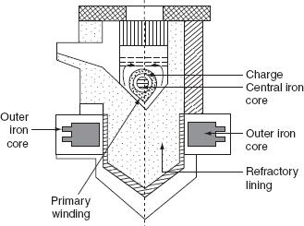

Fig. 4.11 Vertical core type furnace (Ajax–Wyatt induction furnace)

Vertical core avoids the pinch effect due to the weight of the charge in the main body of the crucible. The leakage reactance is comparatively low and the power factor is high as the magnetic coupling is high compared to direct core type.

There is a tendency of molten metal to accumulate at the bottom that keeps the secondary completed for a vertical core type furnace as it consists of narrow V-shaped channel.

The inside layer of furnace is lined depending upon the type charge used. Clay lining is used for yellow brass and an alloy of magnesia and alumina is used for red brass.

The top surface of the furnace is covered with insulating material, which can be removed for admitting the charge. Necessary hydraulic arrangements are usually made for tilting the furnace to take out the molten metal. Even though it is having complicated construction, it is operating at power factor of the order of 0.8–0.83. This furnace is normally used for the melting and refining of brass and non-ferrous metals.

Advantages

- Accurate temperature control and reduced metal losses.
- Absence of crucibles.

- Consistent performance and simple control.
- It is operating at high power factor.

- Pinch effect can be avoided.

  - Indirect core type furnace

This type of furnace is used for providing heat treatment to metal. A simple induction furnace with the absence of core is shown in Fig. 4.12.
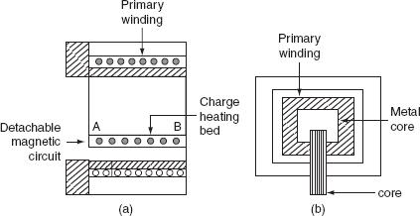

Fig. 4.12 Indirect core ype furnace

The secondary winding itself forms the walls of the container or furnace and an iron core links both primary and secondary windings.
The heat produced in the secondary winding is transmitted to the charge by radiation. An oven of this type is in direct competition with ordinary resistance oven.
It consists of a magnetic circuit AB is made up of a special alloy and is kept inside the chamber of the furnace. This magnetic circuit loses its magnetic properties at certain temperature and regains them again when it is cooled to the same temperature.
When the oven reaches to critical temperature, the reluctance of the magnetic circuit increases many times and the inductive effect decreases thereby cutting off the supply heat. Thus, the

temperature of the furnace can be effectively controlled. The magnetic circuit ‘AB’ is detachable type that can be replaced by the other magnetic circuits having critical temperatures ranging between 400°C and 1,000°C. The furnace operates at a pf of around 0.8.
The main advantage of such furnace is wide variation of temperature control is possible.

Coreless type induction furnace

It is a simple furnace with the absence core is shown in Fig. 4.13. In this furnace, heat developed in the charge due to eddy currents flowing through it.
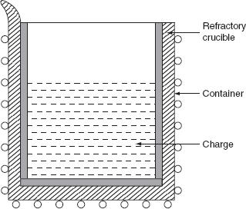

Fig. 4.13 Coreless induction furnace

The furnace consists of a refractory or ceramic crucible cylindrical in shape enclosed within a coil that forms primary of the transformer. The furnace also contains a conducting or non-conducting container that acts as secondary.If the container is made up of conducting material, charge can be conducting or non-conducting; whereas, if the container is made up of non-conducting material, charge taken should have conducting properties.When primary coils are excited by an alternating source, the flux set up by these coils induce the eddy currents in the charge. The direction of the resultant eddy current is in a direction opposite to the current in the

primary coil. These currents heat the charge to melting point and they also set up electromagnetic forces that produce a stirring action to the charge.
- The eddy currents developed in any magnetic circuit are given as:
- W_{e} ∝ B_{m}²f²,

where B_{m} is the maximum flux density (tesla), f is the frequency in (Hz), and W_{e} is the eddy current loss (watts).
In coreless furnace, the flux density will be low as there is no core. Hence, the primary supply should have high frequency for compensating the low flux density.
If it is operating at high frequency, due to the skin effect, it results copper loss, thereby increasing the temperature of the primary winding. This necessitates in artificial cooling. The coil, therefore, is made of hollow copper tube through which cold water is circulated.

Minimum stray magnetic field is maintained when designing coreless furnace, otherwise there will be considerable eddy current loss.

The selection of a suitable frequency of the primary current an be given by penetration formula. According to this:

where ‘t’ is the thickness up to which current in the metal has penetrated, ‘ρ’ is the resistivity in Ω-cm,'μ’ is the permeability of the material, and ‘f’ is the frequency in Hz.

For the efficient operation, the ratio of the diameter of the charge (d) to the depth of the penetration of currents (t) should be more than ‘6’, therefore let us take:
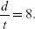

Substitute above in Equation (4.11).
Following are the advantages of coreless furnace over the other furnaces:

- Ease of control.

- Oxidation is reduced, as the time taken to reach the melting temperature is less. o The eddy currents in the charge itself results in automatic stirring.

o The cost is less for the erection and operation. o It can be used for heating and melting.

o Any shape of crucible can be used.

o It is suitable for intermittent operation.

Example 4.8: Determine the amount of energy required to melt 2 ton of zinc in 1 hr, if it operates at an efficiency of 70% specific heat of zinc is equals to 0.1. The latent heat of zinc = 26.67 kcal/kg, the melting point is 480°C, and the initial temperature is 25°C.

Solution:

Weight of zinc = 2 × 1,000 = 2,000 kg.

The heat required raising the temperature from 25°C to 480°C:

- = w × S × (t₂ - t₁)

  - 2,000 × 0.1 × (480-25)

  - 91,000 kcal.

The heat required for melting:

- w × l

- 2,000 × 26.67

- 53,340 kcal.
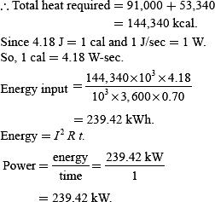

Example 4.9: A high-frequency induction furnace that takes 20 min to melt 1.9 kg of aluminum, the input to the furnace being 3 kW, and the initial temperature is 25°C. Then, determine the efficiency of the furnace.

The specific heat of aluminum = 0.212.
Melting point = 660°C.
The latent heat of the fusion of aluminum = 76.8 kc l/kg

Solution:
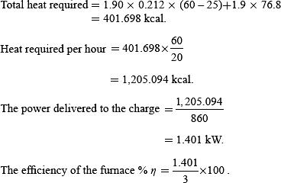

DIELECTRIC HEATING
When non-metallic materials i.e., insulators such as wood, plastics, and china glass are subjected to high-voltage alternating electric field, the atoms get stresses, and due to interatomic friction caused by the repeated deformation and the rotation of atomic structure (polarization), heat is produced. This is known as dielectric loss. This dielectric loss in insulators corresponds to hysteresis loss in ferro-magnetic materials. This loss is due to the reversal of magnetism or magneto molecular friction. These losses developed in a material that has to be heated.
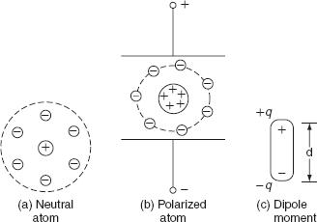
An atom of any material is neutral, since the central positive charge is equals to the negative charge. So that, the centers of positive and negative charges coincide as long as there is no external field is applied, as shown in Fig. (a). When this atom is subjected to the influence of the electric field, the positive charge of the nucleus is acted upon by some force in the direction of negative charges in the opposite direction. Therefore, the effective centers of both positive and negative charges no longer coincident as shown in Fig. (b). The electric charge of an atom equivalent to Fig.(b) is shown in Fig. (c).

Fig. Polarization
This gives raise to an electric dipole moment equal to P = q d, where d is the distance between the two centers and q is the charge on the nucleus.Now, the atom is said to be polarized atom. If we apply alternating voltage across the capacitor plate, we will get alternating electric field.Electric dipoles will also try to change their orientation according to the direction of the impressed electric field. In doing so, some energy will be wasted as inter-atomic friction, which is called dielectric loss.As there is no perfect conductor, so there is no perfect insulator. All the dielectric materials can be represented by a parallel combination of a leakage resistor ‘R’ and a capacitor ‘C’ as shown in Fig. 4.15 (a) and (b).
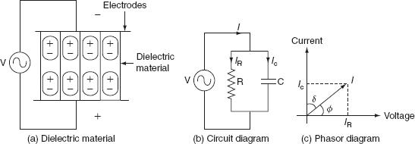

Fig. Dielectric heating

If an AC voltage is applied across a piece of insulator, an electric current flows; total current ‘I’ supposed to be made p of two components I_{C} and I_{R}, where I_{C} is the capacitive current leading the applied vol age by 90° and I_{R} is in phase with applied voltage as shown in Fig.
4.15(c).
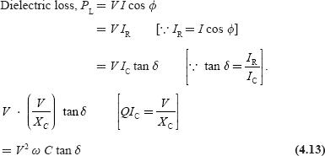

where ‘V' is the applied voltage in volts, ‘f’ is the supply frequency in Hz, ɛ₀ is the absolute permittivity of the medium = 8.854 × 10⁻¹² F/m, ɛ_{r} is the relative permittivity of the medium = 1 for free space, A is the area of the plate or electrode (m²), d is the thickness of the dielectric medium, and δ is the loss angle in radian.

From Equation (4.14):

Normally frequency used for dielectric heating is in the range of 1–40 MHz. The use of high voltage is also limited due to the breakdown voltage of thin diele tric that is to be heated, under normal conditions; the voltage gradient used is limited to 18 kV/ m.

The advantages of the dielectric heating

- The heating of the non-conducti g materi ls is very rapid. o The uniform heating of material is possible.

o Heat is produced in the whole mass of the material.

The applications of he dielectric heating

- The drying of paper, wood, etc. o The gluing of wood.

o The heat-sealing of plastic sheets.

o The heating for the general processing such as coffee roasting and chocolate industry. o The heating for the dehydration such as milk, cream, and vegetables.

o The preparation of thermoplastic resins. o The heating of bones and tissues.

o Diathermy, i.e., the heat treatment for certain body pains and diseases, etc. o The sterilization of absorbent cotton, bandages, etc.

o The processing of rubber, synthetic materials, chemicals, etc.

Example 4.12: A piece of insulating material is to be heated by dielectric heating. The size of the piece is 10 × 10 × 3 cm³. A frequency of 30 mega cycles is used and the power absorbed is
400 W. Determine the voltage necessary for heating and the current that flows in the material.
The material has a permittivity of 5 and a power factor of 0.05.

Solution:

The capacitance offered by the material is given by:
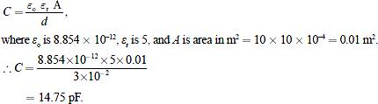

In the phasor diagram, δ is called the dielectric loss angle and φ is called the power factor angle.

From the phasor diagram (Fig. P.4.3):
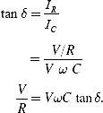
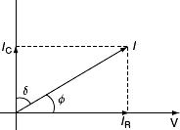

Fig. Phasor diagram

MICROWAVE HEATING
"Microwaves" are a generic term for electromagnetic waves within the frequency range of 300 MHz to 30 GHz (wavelength 1 cm to 1 m). Electromagnetic waves in this frequency band are used in a variety of applications – microwave ovens in homes, industrial heating, cellular phones, UHF TV broadcasts, ship and airplane navigation, radar for weather observation, and aerospace communications.
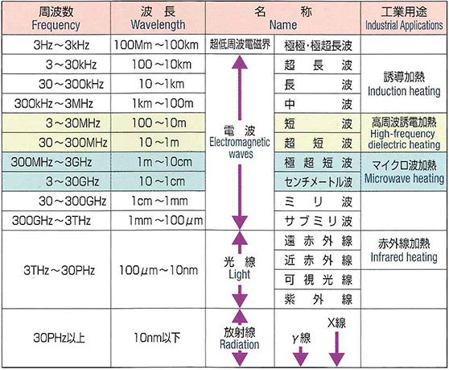
Kinds of Electromagnetic Waves

■Principle of Microwave Heating
When an electric field is applied to metal, for example, the flow of electrons (that is, current) does not occur when a so-called insulator is placed within that electrical field for an electric conductor having freely moving electrons. However, the phenomenon of polarization, where positive and minus electric charges are displaced from the equilibrium point, resulting in a separation of the charges, does occur. Substances with this kind of nature are called a "dielectric." As frequency increases, the component electrons of a dielectric spin, collide, vibrate, rub against each other, and otherwise move violently. Changes in polarity at this time are intense, occurring several ten to several hundred million times per second. This energy becomes "heat", which causes heat to be generated inside the dielectric.
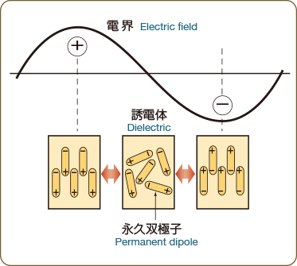
Electrical Field and Movement of Molecules in a Dielectric

■Various types of applicators
There are many different types of applicators for devices that apply microwaves. Select the optimum method best suited to the heated substance parameters, including the following:
- Shape (size, thickness)
- Electrical characteristics (specific conductivity), loss factor (εr・tan δ), water content
- State (liquid, solid, powder, etc.)
- Purpose (preheat, heat treatment, drying, bubbling, vulcanization, etc.)
- Treatment mode (fixed or continuous)
- Pressure control (vacuumed or pressurized)

Working Principle of Microwave Oven
Microwave ovens work on the principle of conversion of electromagnetic energy into thermal energy. Electromagnetic (EM) energy refers to the radiation (waves) comprising an electrical field and magnetic field oscillating perpendicular to each other. When a polar molecule, i.e., a molecule containing opposite charges, falls in the path of these EM radiations, it oscillates to align with them. This causes the energy to be lost from the dipole by molecular friction and collision, resulting in heating. The water molecules present inside our food products go under a similar phenomenon when they come in contact with microwave radiations, heating the food from inside out. Microwaves are electromagnetic radiations with frequencies between 300MHz (0.3 GHz) and 300 GHz, and the corresponding wavelengths ranging from 0.9m to .0009m, respectively. In most of the ovens, the microwave used is of 2.24GHz frequency (i.e., wavelength = 12.2cm). These dimensions allow microwaves to penetrate deep inside the food and cook it from inside, while the temperature of the air present around the food remains constant as air is nonpolar. There is a common misconception that microwaves in a microwave oven excite a natural resonance in water. The frequency of a microwave oven is well below any natural resonance in an isolated water molecule, and in liquid water, those resonances are so smeared out that they’re barely noticeable anyway.
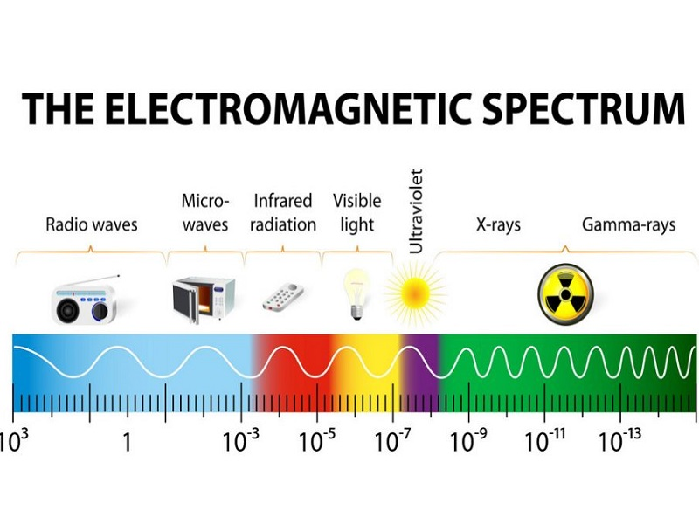

Main Components of Microwave Oven
High Voltage Transformer: Unlike many other household appliances, the microwave oven requires more power than the normal voltage that the home’s electrical wiring carries. To accomplish this, a step-up transformer with a high-voltage output is placed inside the oven. The 240V supply is jumped to a few thousand volts, which is then fed to the cavity magnetron.
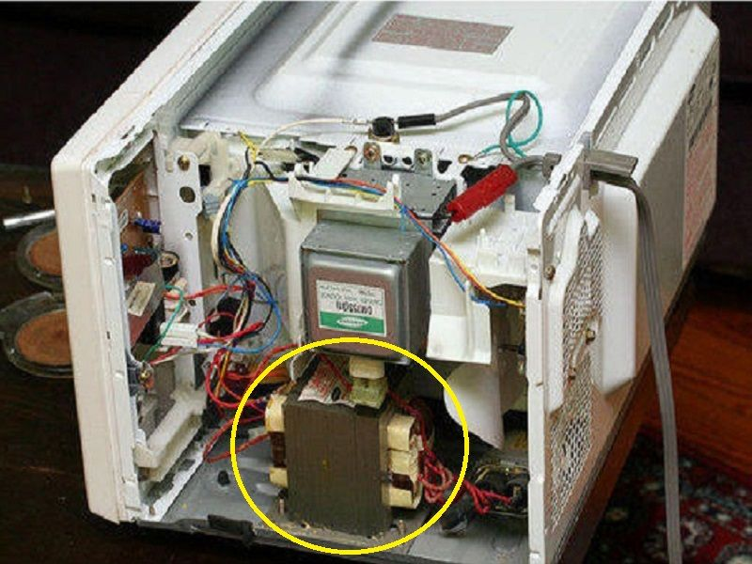
Cavity Magnetron: A cavity magnetron is a high-powered vacuum tube that transforms the electrical energy into long-range microwave radiations, and hence it is the most important component of a microwave oven.
Micro-controller: A microcontroller is something that enables communication between a user and a machine. It is a controlling unit that contains one or more processing cores along with memory and programmable input/output peripherals. It processes the instructions that a user gives to the microwave oven and also displays them on a seven-segment display or a LED screen, depending on the model of the oven.

WaveGuide: As the name suggests, a waveguide is a hollow metallic tube that guides the waves generated at the magnetron’s output toward the cavity (the place where we place the food).

Cooling Fan: Cooling fans reduce the magnetron’s operating temperature and ensure its efficacy and longevity.

Working Mechanism
The process of heating food in the microwave oven is fairly simple; however, the mechanism involved in that process is somewhat a typical. After the generation of microwaves at the magnetron, they are guided by the waveguide towards the food inside the cavity. The microwaves penetrate through the surface of the food and reach the water molecules present inside it. As the orientation of the electric field changes over time, the polar molecules of water attempt to follow the field by changing their orientation inside the material to line up along the field lines in an energetically favourable configuration (namely, with the positive side pointing in the same direction as the field lines). As these molecules change direction rapidly (millions of times per second at least), they gain energy, which increases the temperature of the material. This process is called dielectric heating. The microwave energy diminishes according to the inverse square law, and therefore, the cavity chamber, where we place food, is designed in such a way that it carries out the maximum efficiency of the heating effect of microwaves. Furthermore, most of the microwave ovens come with a door switch that does not allow the process to initiate until the door is completely sealed.

Advantages of Microwave Oven
- The volumetric heating process of microwaves is their most prominent characteristic. In the conventional cooking method, the heat must spread inwards from the surface of the food item, whereas the spread of heat in the case of microwave oven is done in a controlled manner with the help of the microwaves.
- It’s a quick and convenient method of heating food and leftovers.
- Since microwaves can only interact with polar substances like water, they cannot affect the nutritional value of those ingredients that are non-polar. Other conventional cooking methods, however, may destroy some polar as well as non-polar ingredients during the process.
- The user interface and micro-controller facilitate precise control over the cooking temperature.
- The ease of the cooking process in a microwave oven also results in easier cleaning of the equipment after use.

Disadvantages of Microwave Oven
- It is important to take care of what kind of utensils are being used in a microwave. A dish that is not microwave-safe will set off a chemical reaction between the food and the container.
- The cost of equipment is high in comparison to other conventional cooking methods.
- Microwave leakage may lead to electromagnetic interference with other electrical equipment present in the surrounding vicinity. The pacemakers installed in some patients are particularly vulnerable to such radiation leakage.
- Microwave radiation can heat body tissue the same way it heats food. Exposure to high levels of microwaves can cause a painful burn. In particular, the eyes and the testes are vulnerable to microwave heating because there is relatively little blood flow in them to carry away excess heat.
- Another disadvantage of microwaves is that they have limited capacity and because of this, they are not the best option for large families.

Precautions While Using Microwave Oven

- Like many other electrical appliances, it is important to follow the manufacturer’s instruction manual for recommended operating procedures and safety precautions for your oven model.
- Use microwave-safe cookware specially manufactured for use in the microwave oven.
- A microwave oven should not be operated with an open, bent, or broken door.
- To avoid any mishappening, it is recommended not to stand directly in the front of a microwave oven while it is operating.
- The liquids should not be heated longer than the recommended temperature as it can cause the water vapors to reach the electric components and interfere with their working.
- It is essential to periodically clean the cavity with water and mild detergent. It is recommended to not use scouring pads, steel wool, or other abrasives for the cleaning process.

Solar Heating

What Is Solar Heating?
Solar heating refers to the renewable energy system that collects energy from the sun in the form of heat rather than using the sun’s energy to produce electricity, as is the case with solar photovoltaics. Solar heating systems can be used to provide space heating and water heating to be used in residential, commercial, or industrial facilities.
In the case of solar water heating (SWH) systems, heated water is used in showers, kitchen and bathroom faucets, swimming pools, washing machines, Jacuzzis, and other appliances that require warm water. Solar space heating techniques circulate the heated liquid in a radiant heat system through piping in the walls or floors to allow the heat to naturally warm indoor spaces.
Today, there are also solar heaters that passively warm air instead of a liquid, which are commonly used in the UK and other European countries. By warming external air and then circulating it indoors, these systems provide a unique method of space heating using renewable energy.
These are two solar thermal techniques that are commonly used:
- Passive solar heating:This technique relies on the natural tendency for water to circulate freely as some of it warms (in the sun) while some cools. There are no mechanical parts used in passive solar heating systems. Passive systems are typically less costly and less complex than active systems. However, when retrofitting a building, active systems might be the only option for obtaining solar energy. Passive solar space heating takes advantage of warmth from the sun through design features, such as large south-facing windows, and materials in the floors or walls that absorb warmth during the day and release that warmth at night when it is needed most. A sunspace or greenhouse is a good example of a passive system for solar space heating.
Active solar heating:In these systems, pumps and other mechanical components use electricity to circulate water or a heat medium through the system.Active solar space-heating systems consist of collectors that collect and absorb solar radiation combined with electric fans or pumps to transfer and distribute that solar heat. Active systems also generally have an energy-storage system to provide heat when the sun is not shining. The two basic types of active solar space-heating systems use either liquid or air as the heat-transfer medium in their solar energy collectors.
- 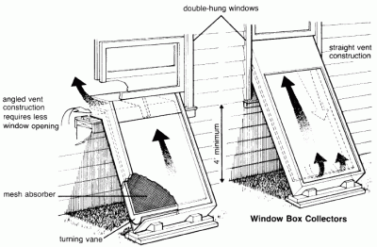
- Figure 1: Convective air heaters (Source: Knowledge publications)
- An overview of examples of SWH projects applied in industrialised countries can be found on the IEA Solar Heating and Cooling Internet site. Even though solar thermal is used today mainly for providing hot water to households and pools, Vannoni et al (2008) demonstrate its significance in the final energy consumption in the industrial sectors. A great share of the industries' heat demand is needed in the low and medium temperature range, such as food – including wine and beverage, textile, transport equipment, metal and plastic treatment, chemical and for several processes (cleaning, drying, evaporation and distillation, blanching, pasteurisation, sterilisation, cooking, melting, painting, surface treatment).

SolarWaterHeater
Construction
A typical domestic solar water heater consists of a hot water storage tank and one or more flat plate collectors. Inlet and outlet pipes are connected to water tank which is insulated to avoid heat loss. Material of construction of tube is copper in side collector. Glass cover is provided on the collector. Water is place on the metal structure at the top and flat plate collectors are the bottom facing the sun.
Working
The collectors are glazed on the sun facing side to allow solar radiation to come in. A black absorbing surface (absorber) inside the flat plate collectors absorbs solar radiation and transfers the energy to water flowing through it. A black surface heats up when left in the sun, by absorption of solar radiation; The good absorption property of black surfaces is used to improve solar energy absorption in a solar heater Heated water is collected in the tank which is insulated to prevent heat loss. Circulation of water from the tank through the collectors and back to the tank continues automatically due to density difference between hot and cold water (thermosyphon effect).

Solar cooker
We normally use a stove or an oven for cooking vegetables, meat and rice. Using a solar cooker, we cook the same things, but by using sunlight instead of gas or electricity. In the article, let us discuss the working and construction of a solar cooker.

Using Light to Cook
Sunlight isn’t hot in and of itself. It is radiation generated by fluctuating electric and magnetic fields. The sunlight to heat conversion occurs when the photons of light waves interact with molecules of the substance. The electromagnetic radiation emitted by the Sun possesses energy in them. When they strike, the energy causes the molecules of the matter to vibrate. The molecules get excited and jump to higher levels. This activity generates heat.

Working Principle

Concentrating Sunlight:
A mirror surface with high specular reflection is used to concentrate and channelise light from the sun into a small cooking space. The sunlight can be concentrated by several orders of magnitude, producing magnitudes high enough to melt salt and metal. For household solar cooking applications, such high temperatures are not required. Solar cookers available in the market are designed to achieve temperatures of 65⁰C to 400⁰C.

Converting Light Energy to Heat Energy:
The concentrated sunlight is focused onto a receiver such as a cooking pan. The interaction between the light energy and the receiver material helps to converts light into heat by a process called conduction. The conversion is maximised by making use of materials that conduct and retain heat. Pots and pans used in solar cookers should be matte black in colour to maximise the absorption.

Trapping Heat Energy:
The occurrence of convection is reduced by isolating the air inside the cooker from the air outside. Using a glass lid on the pot enhances light absorption from the top of the pan and decreases the convection energy loss along with improving heat holding capacity of the cooker. The glazing taps the incoming sunlight but is opaque to escaping infrared thermal rays.

Box-Type Solar Cooker
The most commonly used form of solar cooker is the box-type solar cooker. In this section, we will be discussing the construction and working principle of a box-type solar cooker.
A box-type solar cooker consists of the following components:
- Black Box – The box is an insulated metal or wooden box which is painted black from the inside to absorb more heat.
- Glass Cover – A cover made two sheets of toughened glass held together in an aluminium frame is used as a cove for box B.
- Plane Mirror reflector – The plane mirror reflector is fixed to the box B with the help of hinges. The mirror reflector can be positioned at any desired angle to the box. The mirror is positioned so as to allow the reflected sunlight to fall on the glass cover of the box.
- Cooking Containers – A set of aluminium containers blackened from the outside are kept in box B.
The solar cooker placed in sunlight and a plane mirror reflector is adjusted in a way such that the strong beam of sunlight enters the box through the glass sheet. The blackened metal surfaces in the wooden box absorb infra-red radiations from the beam of sunlight and heat produced raises the temperature of a blackened metal surface to about 100°C.
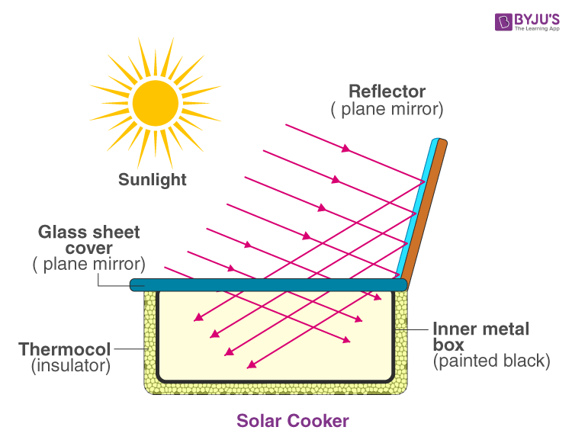
Solar Cooker
The food absorbs heat from the black surface and gets cooked. The thick glass sheet does not allow the heat to escape and thus, helps in raising the temperature in the box to a sufficiently high degree to cook the food.

Advantages & Disadvantages of Solar Cooker

Pros
- Solar cookers use no fuel. This saves cost as well as the environment by not contributing to pollution.
- Reduces carbon footprint by cooking without carbon dioxide-based fuels.

Cons
- Solar cookers are less useful in cloudy weather.
- Some solar cookers take longer to cook food than a conventional stove or an oven.
- Some solar cookers are affected by strong winds which can slow the cooking process.
- It might get difficult to cook some thick foods such as large roasts and loaves of bread.
Top of Form

Bottom of Form

SHORT QUESTIONS AND ANSWERS

Q1 Give any two advantages of electric heating.

  - Electric heating equipment is cheaper; it does not require much skilled persons so maintenance cost is less.

  - In this heating, the temperature can be controlled and regulated accurately either manually or automatically

Q2 What are the modes of the transfer of heat?

The modes of the transfer of heat are:
Conduction.

Convection.

Radiation.

Q3 What is an oven?

Oven is mean that a low-temperature heating chamber with pr vision for ventilation.

Q4 Define conduction.

The process of heat transfers from one part of substance to another part without movement in the molecules of subst nce. The rate of conduction of heat along the substance depends upon temper ture gr dient.

Q5 Define convection.

The process of heat transfer takes place from one part to another part of a substance or a fluid due o he act al motion of the molecules. The rate of conduction of the heat depends mainly on the difference in the fluid density at different temperatures.

Q6Define radiation.

The process of heat transfers from the source to the substance to be heated without heating the medium in between the source and the substance.

Q7What are the essentials requirements of heating elements?

The materials used for heating element should have:

  - High-specific resistance.

  - High-melting point.

  - High-mechanical strength.

  - Free from oxidation.

Q8What is the Stefan's formula for heat dissipation?

Stefan's law for heat dissipation is:

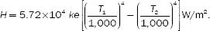

What are the causes of the failure of the heating elements?

The failure of the heating element may cause due to:

- The formation of hotspots.

- The oxidation of the element and the intermittency of operation.

- The embitterment caused by gain growth

- Contamination and corrosion.

Q9What is meant by resistance heating?

The process of heating the charge or substance by the heat produced due to the resistance offered by the charge or heating element.

Q10What is meant by induction heating?

The process of heating the material due to the heat developed by the currents induced in the material by electromagnetic induction process.

Q11What is meant by dielectric heating?

The process of heating non-metallic materials, i.e., the insulat rs such as wood, plastics, and china clay due to the heat developed in the material when they are subjected to high voltage alternating electric field, the atoms get stresses and due to inter-atomic friction caused by the repeated deform tion and rotation of atomic structure.

Q12What are the various losses occurri g in resist nce oven?

The heat produced in the heati g elements, not only raises the temperature of charge to desired value, b t also used to overcome the losses occurring due to:

0. The heat sed in raising the temperature of oven (or) furnace.

- The heat used in raising the temperature of containers (or) carriers.

- The heat conducted through the walls.

- The heat loss due to the opening of oven door.

Q13List out various methods of controlling the temperature of resistance heating.

The temperature of the furnaces can be controlled either by:

- Varying the resistance of elements.

- Varying the applied voltage to the elements or the current flowing through the elements

- Varying the ratio of the on-and-off times of supply.

Q14What are the types of arc furnaces?

There are two types of arc furnaces and they are:

- Direct arc furnace.

- Indirect arc furnace.

Q14What is the condition for the maximum power output of electric arc furnace?

The condition for the maximum power output of electric arc furnace is:

Q14.What is pinch effect?

The formation of bubbles and voids in the charge to be heated by the electromagnetic induction due to high-electromagnetic forces, which causes the interruption of secondary circuit. This effect is known as pinch effect.

Q15.What is high-frequency eddy current heating?

The process of heating any material by the heat developed due to the conversion of electromagnetic energy into heat energy.

Q16.How amount of heat is controlled in high-frequency eddy current heating?

The amount of heat is controlled by controlling the supply frequency and the flux density in high-frequency eddy current heating.

UNIT 3

Electric Welding

INTRODUCTION

Welding is the process of joining two pieces of metal or non-metal together by heating them to their melting point. Filler metal may or may not be used to join two pieces. The physical and mechanical properties of a material to be welded such as melting temperature, density, thermal conductivity, and tensile strength take an important role in welding. Depending upon how the heat applied is created; we get different types of welding such as thermal welding, gas welding, and electric welding. Here in this chapter, we will discuss only about the electric welding and some introduction to other modern welding techniques. Welding is nowadays extensively used in automobile industry, pipe-line fabrication in thermal power plants, machine repair work, machine frames, etc.
3.2 Welding method 3.2.1 Principles of resistance welding, types – spot, projection, seam and butt welding, welding equipment 3.2.2 Principle of arc production, electric arc welding, characteristics of arc; carbon arc, metal arc, hydrogen arc welding method and their applications. Power supply requirement. Advantages of using coated electrodes, comparison between AC and DC arc welding, welding control circuits, welding of aluminum and copper

  - Advantages of electric welding

ADVANTAGES AND DISADVANTAGES OF WELDING

Some of the advantages of welding are:

- Welding is the most economical method to permanently join two metal parts.

- It provides design flexibility.

- Welding equipment is not so costly.
- It joins all the commercial metals.

- Both similar and dissimilar metals can be joined by welding.
- Portable welding equipment are available.

Some of the disadvantages of welding are:

- Welding gives out harmful radiations and fumes
- Welding needs internal inspection.

- If welding is not done carefully, it may result in the distortion of workpiece.
- Skilled welding is necessary to produce good welding.

  - Welding method
ELECTRIC WELDING

It is defined as the process of joining two metal pieces, in which the electrical energy is used to generate heat at the point of welding in order to melt the joint.

The classification of electric welding process is shown in fig.

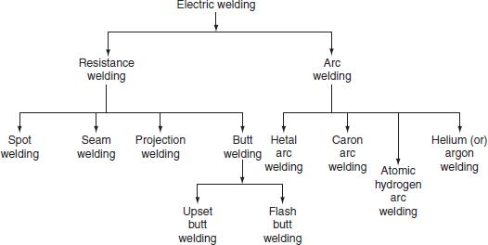

Fig. Classification of electric welding

The selection of proper welding process depends on the following factors.

- The type of metal to be joined.

- The techniques of welding adopted. o The cost of equipment used.

- The nature of products to be fabricated.

RESISTANCE WELDING

Resistance welding is the process of joining two metals together by the heat produced due to the resistance offered to the flow of electric current at the junctions of two metals. The heat produced by the resistance to the flow of current is given by:

H = I²Rt,

where I is the current through the electrodes, R is the contact resistance of the interface, and tis the time for which current flows.

Here, the total resistance offered to the flow of current is made up of:

- The resistance of current path in the work.

- The resistance between the contact surfaces of the parts being welded.

- The resistance between electrodes and the surface of parts being welded.
In this process of welding, the heat developed at the contact area between the pieces to be welded reduces the metal to plastic state or liquid state, then the pieces are pressed under high mechanical pressure to complete the weld. The electrical voltage input to the welding varies in between 4 and 12 V depending upon area, thickness, composition, etc. and usually power ranges from about 60 to 180 W for each sq. mm of area.
Any desired combination of voltage and current can be obtained by means of a suitable transformer in AC; hence, AC is found to be most suitable for the resistance welding. The magnitude of current is controlled by changing the primary voltage of the welding transformer, which can be done by using an auto-transformer or a tap-changing transformer. Automatic arrangements are provided to switch off the supply after a pre-determined time from applying the pressure, why because the duration of the current flow through the work is very important in the resistance welding.
The electrical circuit diagram for the resistance welding is shown in Fig. 5.2. This method of welding consists of a tap-changing transformer, a clamping device f r h lding the metal pieces, and some sort of mechanical arrangement for forcing the pie es to f rm a complete weld.

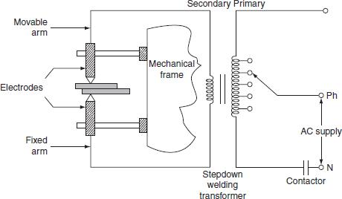

Fig. Electric circuit for resistance welding

Advantages

- Welding process is rapid and simple.

- Localized heating is possible, if required. o No need of using filler metal.

- Both similar and dissimilar metals can be welded. o Comparatively lesser skill is required.

- Maintenance cost is less.

- It can be employed for mass production.

However, the resistance welding has got some drawbacks and they are:

- Initial cost is very high.
- High maintenance cost.

- The workpiece with heavier thickness cannot be welded, since it requires high input current.

Applications

o It is used by many industries manufacturing products made up of thinner gauge metals.

- It is used for the manufacturing of tubes and smaller structural sections.

Types of resistance welding

Depending upon the method of weld obtained and the type of electrodes used, the resistance welding is classified as:

- Spot welding.

- Seam welding.

- Projection welding.

- Butt welding.

(i) Spot welding

Spot welding means the joining of two metal sheets and fusing them together between copper electrode tips at suitably spaced intervals by means of heavy electric current passed through the electrodes as shown in Fig. 5.3.

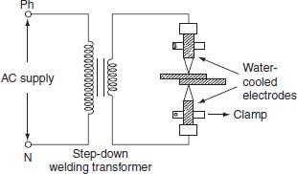

Fig. 5.3 Spot welding

This type of joint formed by the spot welding provides mechanical strength and not air or water tight, for such welding it is necessary to localize the welding current and to apply sufficient pressure on the sheet to be welded. The electrodes are made up of copper or copper alloy and are water cooled. The welding current varies widely depending upon the thickness and composition of the plates. It varies from 1,000 to 10,000 A, and v ltage between the electrodes is usually less than 2 V. The period of the flow of current v ries widely depending upon the thickness of sheets to be joined. A step-down transfor er is used to reduce a high-voltage and low-current supply to low-voltage and high-current supply required. Since the heat developed being proportional to the product of weldi g ti e and square of the current. Good weld can be obtained by low currents for longer dur tion nd high currents for shorter duration; longer

welding time usually pro uces stro ger weld but it involves high energy expenditure, electrode maintenance, and lot of istortion of workpiece.

When voltage applied across the electrode, the flow of current will generate heat at the three junctions, i.e., heat developed, between the two electrode tips and workpiece, between the two workpieces to be joined as shown in Fig. 3.3. The generation of heat at junctions 1 and 3 will effect electrode sticking and melt through holes, the prevention of electrode striking is achieved by:

- Using water-cooled electrodes shown in Fig. 5.4. By avoiding the heating of junctions 1 and 3 electrodes in which cold water circulated continuously as shown in Fig. 5.3.

  - The material used for electrode should have high electrical and thermal conductivity. Spot welding is widely used for automatic welding process, for joining automobile parts, joining and fabricating sheet metal structure, etc.

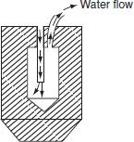

Fig. Water cooled electrode

(ii) Seam welding

Seam welding is nothing but the series of continuous spot welding. If number spots obtained by spot welding are placed very closely that they can overlap, it gives rise to seam welding.

In this welding, continuous spot welds can be formed by using wheel type or roller electrodes instead of tipped electrodes as shown in Fig. 5.5.
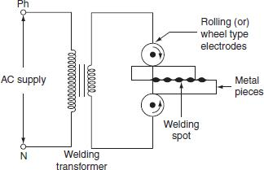

Fig. 5.5 Seam welding

Seam welding is obtained by keeping the job under electrodes. When these wheel type electrodes travel over the metal pieces which are under pressure, the current passing between them heats the two metal pieces to the plastic state and results into continuous spot welds.

In this welding, the contact area of electrodes should be small, which will localize the current pressure to the welding point. After forming weld at one point, the weld so obtained can be cooled by splashing water over the job by using cooling jets.

In general, it is not satisfactory to make a continuous weld, for which the flow of continuous current build up high heat that causes burning and wrapping of the metal piece. To avoid this difficulty, an interrupter is provided on the circuit which turns on supply for a period sufficient to heat the welding point. The series of weld spots depends upon the number of welding current pulses.

The two forms of welding currents are shown in Fig. 5.6(a) and (b).
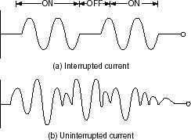

Fig. 5.6 Welding current

Welding cannot be made satisfactorily by using uninterrupted or un-modulated current, which builds up high heat as the welding progress; this will over heat the workpiece and cause distortion.

Seam welding is very important, as it provides leak proof joints. It is usually employed in welding of pressure tanks, transformers, condensers, evaporators, air craft tanks, refrigerators, varnish containers, etc.

(iii) Projection welding

It is a modified form of the spot welding. In the projection welding, both current and pressure are localized to the welding points as in the spot welding. But the only difference in the projection welding is the high mechanical pressure applied on the metal pieces to be welded, after the formation of weld. The electrodes used for such welding are flat metal plates known as platens.

The two pieces of base metal to be weld are held together in between the two platens, one is movable and the other is fixed, as shown in Fig. 5.7.
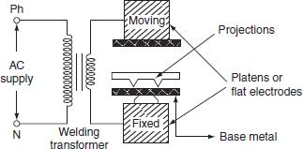

Fig. 5.7 Projection welding

One of the two pieces of metal is run through a machine that makes the bumps or projections of required shape and size in the metal. As current flows through the two metal parts to be welded, which heat up and melt. These weld points soon re ch the plastic state, and the projection touches the metal then force pplied by the two flat electrodes forms the complete weld.

The projection welding nee s no protective atmosphere as in the spot welding to produce successful results. This wel ing process reduces the amount of current and pressure in order to join two metal surfaces, so that there is less chance of distortion of the surrounding areas of the weld zone. Due to his reason, it has been incorporated into many manufacturing process.

The projection welding has the following advantages over the spot welding.

- Simplicity in welding process.

- It is easy to weld some of the parts where the spot welding is not possible. o It is possible to join several welding points.

o Welds are located automatically by the position of projection.

o As the electrodes used in the projection welding are flat type, the contact area over the projection is sufficient.

This type of welding is usually employed on punched, formed, or stamped parts where the projection automatically exists. The projection welding is particularly employed for mass production work, i.e., welding of refrigerators, condensers, crossed wire welding, refrigerator racks, grills, etc.

(iv) Butt welding

Butt welding is similar to the spot welding; however, the only difference is, in butt welding, instead of electrodes the metal parts that are to be joined or butted together are connected to the supply.

The three basic types of the butt welding process are:

- Upset butt welding.

  - Flash butt welding.

  - Percussion butt welding.

(a) Upset butt welding

In upset welding, the two metal parts to be welded are joined end to end and are connected across the secondary of a welding transformer as shown in Fig. 5.8.
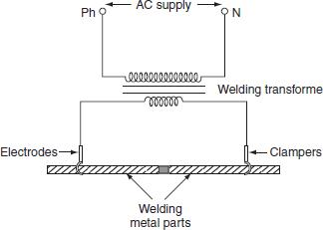

Fig. 5.8 Upset butt welding

Due to the contact resistance of the metals to be welded, heating effect is generated in this welding. When current is made to flow through the two electrodes, heat will develop due to the contact resistance of the two pieces and then melts. By applying high mechanical pressure either manually or by toggle mechanism, the two metal pieces are pressed. When jaw-type electrodes are used that introduce the high currents without treating any hot spot on the job.

This type of welding is usually employed for welding of rods, pipes, and wires and for joining metal parts end to end.

(b) Flash butt welding

Flash butt welding is a combination of resistance, arc, and pressure welding. This method of welding is mainly used in the production welding. A simple flash butt welding arrangement is shown in Fig. 5.9.
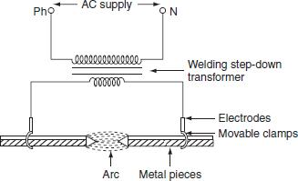

Fig. 5.9 Flash butt welding

In this method of welding, the two pieces to be welded are brought very nearer to each other under light mechanical press re. These two pieces are placed in a conducting movable clamps. When high current is passed through the two metal pieces and they are separated by some distance, then arc established between them. This arc or flashing is allowed till the ends of the work pieces reach melting temperature, the supply will be switched off and the pieces are rapidly brought together under light pressure. As the pieces are moved together, the fused metal and slag come out of the joint making a good solid joint.

Following are the advantages of the flash butt welding over the upset welding.

- Less requirement of power.

- When the surfaces being joined, it requires only less attention.

- Weld obtained is so clean and pure; due to the foreign metals appearing on the surfaces will burn due to flash or arc.

(c) Percussion welding

It is a form of the flash butt welding, where high current of short duration is employed using stored energy principle. This is a self-timing spot welding method.

Percussion welding arrangement consists of one fixed holder and the other one is movable. The pieces to be welded are held apart, with the help of two holders, when the movable clamp is released, it moves rapidly carrying the piece to be welded. There is a sudden discharge of electrical energy, which establishes an arc between the two surfaces and heating them to their melting temperature, when the two pieces are separated by a distance of 1.5 mm apart. As the pieces come in contact with each other under heavy pressure, the arc is extinguished due to the percussion blow of the two parts and the force between them affects the weld. The percussion welding can be obtained in two methods; one is capacitor energy storage system and the other is magnetic energy storage system. The capacitor discharge circuit for percussion welding is shown in Fig. 5.10.
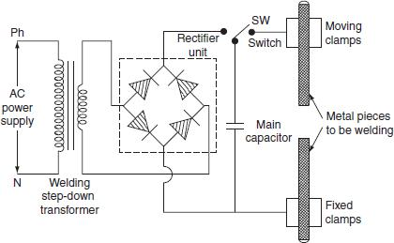

Fig. 5.10 Capacitor discharge circuit for percussion welding

The capacitor ‘C’ is charged to about 3,000 V from a controlled rectifier. The capacitor is connected to the primary of welding transformer through the switch and will discharge. This discharge will produce high transient current in the secondary to join the two metal pieces.

Percussion welding is difficult to obtain uniform flashing of the metal part areas of the cross-section grater than 3 sq. cm. Advantage of this welding is so fast, extremely shallow of heating is

obtained with a span of about 0.1 sec. It can be used for welding a large number of dissimilar metals.

Applications

- It is useful for welding satellite tips to tools, sliver contact tips to copper, cast iron to steel, etc. o Commonly used for electrical contacts.

o The metals such as copper alloys, aluminum alloys, and nickel alloys are percussion welded.

CHOICE OF WELDING TIME

The successful welding operation mainly depends upon three factors and they are:

- Welding time.

- Welding current.

- Welding pressure.

Figure 5.11 shows how the energy input to the welding process, welding strength, and welding current vary with welding time.
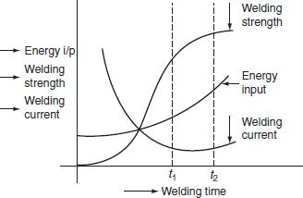

Fig. 5.11 Performance characteristics of electric welding

The heat developed during welding process is given by H = I²Rt. Here both welding current and welding time are critical variables.

Greater the welding current, the shorter the welding time required is; usually longer welding time produces stronger weld but there is lot of distortion of work piece and high energy expenditure. From Fig. 5.11, it is to be noted that, from 0 to t₁ sec, there is appreciable increase in welding strength, but after t₂ sec, the increase in the welding time does not appreciably result in the increase in strength; therefore, ‘t₂’ is the optimum welding time. This optimum time varies with the thickness of the material. The optimum times of material (sheet steel) with different thickness are given as:

 | Dimensions of material |  |  | Optimum time
2 × 24 SWG |  |  |  | 8 cycles
 | 2 × 14 SWG |  |  | 20 cycles
2¼″ |  |  |  | 2 sec

Therefore, from the above discussion, it is observed that shorter welding times with strength and economy are always preferable.

Electromagnetic storage welding circuit is shown in Fig. 5.12. In this type of welding, the energy stored in the magnetic circuit is used in the welding operation.
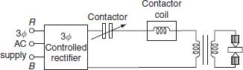

Fig. 5.12 Magnetic energy storage welding circuit

In this system, rectifier is fed from AC supply, which is converted to DC, the DC voltage of rectifier is controlled in such a way that, voltage induced in the primary without causing large current in the secondary of transformer on opening the contactor switch, DC on longer flows, there is rapid collapse of magnetic field, which induces very high current in the secondary of a transformer. Induced currents in the secondary of the transformer flow through the electrodes that develop heat at the surface of the metal and so forming the complete weld.

ELECTRIC ARC WELDING

Electric arc welding is the process of joining two metallic pieces or melting of metal is obtained due to the heat developed by an arc struck between an electrode and the metal to be welded or between the two electrodes as shown in Fig. 5.13 (a).
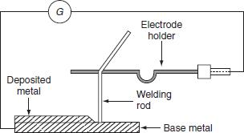

Fig. Arrangement of electric welding equipment

In this process, an electric arc is produced by bringing two conductors (electrode and metal piece) connected to a suitable source of electric current, momentarily in contact and then separated by a small gap, arc blows due to the ionization and give intense heat.

The heat so developed is utilized to melt the part of work piece and filler metal and thus forms the weld.

In this method of welding, no mechanical pressure is employed; therefore, this type of welding is also known as 'non-pressure welding’.

The length of the arc required for welding depends upon the following factors:

- The surface coating and the type of electrodes used. o The position of welding.

o The amount of current used.

When the supply is given across the conductors separated by some distance apart, the air gap present between the two conductors gets ionized, as the arc welding is in progress, the ionization of the arc path and its surrounding area increases. This increase in ionization decreases the resistance of the path. Thus, current increases with the decrease in voltage of arc. This V-

I characteristic of an arc is shown in Fig. (b), it also known as negative resistance characteristics of an arc. Thus, it will be seen that this decrease in resistance with increase in current does not

remain the arc steadily. This difficulty cab be avoided, with the supply, it should fall rapidly with the increase in the current so that any further increase in the current is restricted.

For the arc welding, the temperature of the arc should be 3,500°C. At this temperature, mechanical pressure for melting is not required. Both AC and DC can be used in the arc welding. Usually 70–100 V on AC supply and 50–60 V on DC supply system is sufficient to struck the arc in the air gap between the electrodes. Once the arc is struck, 20–30 V is only required to maintain it.

However, in certain cases, there is any danger of electric shock to the operator, low voltage should be used for the welding purpose. Thus, DC arc welding of low voltage is generally preferred.

Electric arc welding is extensively used for the joining of metal parts, the repair of fractured casting, and the fillings by the deposition of new metal on base metal, etc.

Various types of electric arc welding are:

- Carbon arc welding.

- Metal arc welding.

- Atomic hydrogen arc welding.

- Inert gas metal arc welding.

- Submerged arc welding.

Carbon arc welding

It is one of the processes of arc welding in which arc is struck between two carbon electrodes or the carbon electrode and the base metal. The simple arrangement of the carbon arc welding is shown in Fig. 5.14.
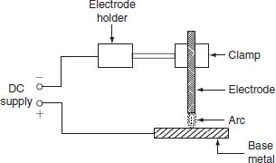

Fig. Carbon arc welding

In this process of welding, the electrodes are placed in an electrode holder used as negative electrode and the base metal being welded as positive. Unless, the electrode is negative relative to the work, due to high temperature, there is a tendency of the particles of carbon will fuse and mix up with the base metal, which causes brittleness; DC is preferred for carbon arc welding since there is no fixed polarity maintained in case of AC.

In the carbon arc welding, carbon or graphite rods are used as electrode. Due to longer life and low resistance, graphite electrodes are used, and thus capable of conducting more current. The arc produced between electrode and base metal; heat the metal to the melting temperature, on the negative electrode is 3,200°C and on the positive electrode is 3,900°C.

This process of welding is normally employed where addition of filler metal is not required. The carbon arc is easy to maintain, and also the length of the arc can be easily varied. One major problem with carbon arc is its instability which can be overcome by using an inductor in the electrode of 2.5-cm diameter and with the current of about of 500–800 A employed to deposit large amount of filler metal on the base metal.

Filler metal and flux may not be used depending upon the type of joint and material to be welded.

Advantages

- The heat developed during the welding can be easily controlled by adjusting the length of the arc. o It is quite clean, simple, and less expensive when compared to other welding process.

- Easily adoptable for automation.

- Both the ferrous and the non-ferrous metals can be welded.

Disadvantages

- Input current required in this welding, for the work piece to rise its temperature to melting/welding

temperature, is approximately double the metal arc welding.

- In case of the ferrous metal, there is a chance of disintegrating the carbon at high temperature and

transfer to the weld, which causes harder weld deposit and brittlement.

- A separate filler rod has to be used if any filler metal is required.

Applications

- It can be employed for the welding of stainless steel with thinner gauges.

- Useful for the welding of thin high-grade nickel alloys and for galvanized sheets using copper silicon manganese alloy filler metal.

Metal arc welding

In metal arc welding, the electrodes used must be of the same metal as that of the work-piece to be welded. The electrode itself forms the filler metal. An electric arc is stuck by bringing the electrode connected to a suitable source of electric current, momentarily in contract with the work pieces to be welded and withdrawn apart. The circuit diagram for the metal arc welding is shown in Fig. 5.15.
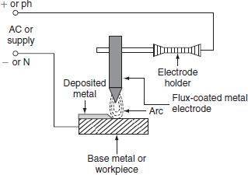

Fig. 5.15 Metal arc welding

The arc produced between the work piece and the electrode results high temperature of the order of about 2,400°C at negative metal electrode and 2,600°C at positive base metal or work piece.

This high temperature of the arc melts the metal as well as the tip of the electrode, then the electrode melts and deposited over the surface of the work piece, forms complete weld.

Both AC and DC can be used for the metal arc welding. The voltage required for the DC metal arc welding is about 50–60 V and for the AC metal arc welding is about 80–90 V

In order to maintain the voltage drop across the arc less than 13 V, the arc length should be kept as small as possible, otherwise the weld will be brittle. The current required for the welding varies from 10 to 500 A depending upon the type of work to be welded.

The main disadvantage in the DC metal arc welding is the presence of arc blow, i.e., distortion of arc stream from the intended path due to the magnetic forces of the non-uniform magnetic field with AC arc blow is considerably reduced. For obtaining good weld, the flux-coated

electrodes must be used, so the metal which is melted is covered with slag produces a non-oxidizing gas or a molten slag to cover the weld, and also stabilizes the arc.

Atomic hydrogen arc welding

In atomic hydrogen arc welding, shown in Fig. 5.16, the heat for the welding process is produced from an electric arc struck between two tungsten electrodes in an atmosphere of hydrogen. Here, hydrogen serves mainly two functions; one acts as a protective screen for the arc and the other acts as a cooling agent for the glowing tungsten electrode tips. As the hydrogen gas passes through the arc, the hydrogen molecules are broken up into atoms, absorbs heat from the glowing tungsten electrodes so that these are cooled.
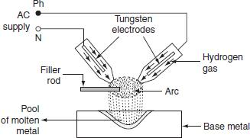

Fig. 5.16 Atomic hydrogen arc welding

But, when the atoms of hydrogen recombine into molecules outside the arc, a large amount of heat is liberated. This extra heat is added to the intense heat of arc, which produces a temperature of about 4,000°C that is sufficient to melt the surfaces to be welded, together with the filler rod if used. Moreover hydrogen includes oxygen and some other gases that might combine with the molten metal and forms oxides and other impurities. Hydrogen also removes oxides from the surface of work piece. Thus, this process is capable of producing strong, uniform, smooth, and ductile welds.

In the atomic hydrogen arc welding, the arc is maintained between the two non-consumable tungsten electrodes under a pressure of about 0.5 kg/cm². In order to obtain equal consumption of electrodes, AC supply is used. Arc currents up to 150 A can be used. High voltage about 300 V is applied for this welding through a transformer. For striking the arc between the electrodes the open circuit voltage required varies from 80 to 100 V.

As the atomic hydrogen welding is too expensive, it is usually employed for welding alloy steel, carbon steel, stainless steel, aluminum, etc.

Inert gas metal arc welding

It is a gas-shielded metal arc welding, in which an electric arc is stuck between tungsten electrode and work piece to be welded. Filler metal may be introduced separately into the arc if required. A welding gun, which carries a nozzle, through this nozzle, inert gas such as beryllium or argon is blown around the arc and onto the weld, as shown in Fig. 5.17. As both beryllium and argon are chemically inert, so the molten metal is protected from the action of the atmosphere by an envelope of chemically reducing or inert gas.
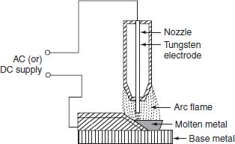

Fig. 5.17 Inert gas metal are welding

As molten metal has an affinity for oxygen and nitrogen, if exposed to the atmosphere, thereby forming their oxides and nitrides, which makes weld leaky and brittle.

Thus, several methods of shielding have been employed. With the use of flux coating electrodes or by pumping, the inert gases around the arc produces a slag that floats on the top of molten metal and produces an envelope of inert gas around the arc and the weld.

Advantages

- Flux is not required since inert gas envelope protects the molten metal without forming oxides and nitrates so the weld is smooth, uniform, and ductile.

- Distortion of the work is minimum because the concentration of heat is possible.

Applications

- The welding is employed for light alloys, stainless steel, etc.

- The welding of non-ferrous metal such as copper, aluminum, etc.

SUBMERGED ARC WELDING

It is an arc welding process, in which the arc column is established between above metal electrode and the work piece. Electric arc and molten pool are shielded by blanket of granular flux on the work piece. Initially to start an arc, short circuit path is provided by introducing steel wool between the welding electrode and the work piece. This is due to the coated flux material, when cold it is non-conductor of the electricity but in molten state, it is highly conductive. Welding zone is shielded by a blanket of flux, so that the arc is not visible. Hence, it is known as 'submerged arc welding’. The arc so produced, melts the electrode, parent the metal and the coated flux, which forms a protective envelope around both the arc and the molten metal.

As the arc in progress, the melted electrode metal forms globules and mix up with the molten base metal, so that the weld is completed. In this welding, the electrode is completely covered by flux. The flux may be made of silica, metal oxides, and other compounds fused together and then crushed to proper size. Therefore, the welding takes place without spark, smoke, ash, etc. Thus, there is no need of providing protective shields, smoke collectors, and ventilating

systems. Figure 5.18 shows the filling of parent metal by the submerged arc welding.
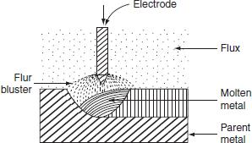

Fig. 5.18 Submerged arc welding

Voltage required for the submerged arc welding varies from 25 to 40 V. Current employed for welding depends upon the dimensions of the work piece. Normally, if DC supply is used employing current ranging from 600 to 1,000 A, the current for AC is usually 2,000 A.

Advantages

- Deep penetration with high-quality weld is possible.
- Job with heavy thickness can be welded.

- The weld so obtained has good ductility, impact strength, high corrosion resistance, etc.
- The submerged arc welding can be done manually or automatically.

Applications

- The submerged arc welding is widely used in the heavy steel plant fabrication work.

- It can be employed for welding high strength steel, corrosion resistance steel, and low carbon steel.
- It is also used in the ship-building industry for splicing and fabricating subassemblies, manufacture of vessels, tanks, etc.

ELECTRON BEAM WELDING

It is one of the processes of the electric welding, in which the heat required for carrying out the welding operation is obtained by the electron bombardment heating.

In the electron bombardment heating, continuous stream of electron is produced between the electron emitting material cathode and the material to be heated. The electrons released from cathode possess KE traveling with high velocity in vacuum of 10⁻³-10⁻⁵ mmHg. When the fast moving electrons hit, the material or work piece releases their KE as heat in the material to be heated. This heat is utilized to melt the metal.

If this process is carried out in high vacuum , without providing any electrodes, gasses, or filler metal, pure weld can be obtained. Moreover, high vacuum is maintained around the (filament) cathode. So that, it will not burn up a d also produces continuous stable beam. If a vacuum was not used, the electron would strike the small partials in the atmosphere, reducing their velocity and also the heating ability. Thus, the operation should be performed in vacuum to present the reduction of the velocity of electron. That's why this is also called as 'vacuum electron beam welding’. The power released by the electron beam is given by:

P = nqv watts,

where n is the number of charged particles, q is the charge in coulombs per meter, and v is the voltage required to accelerate the electrum from rest.

The electron beam welding (Fig. 5.19) process requires electron-emitting heating filament as cathode, focusing lens, etc.

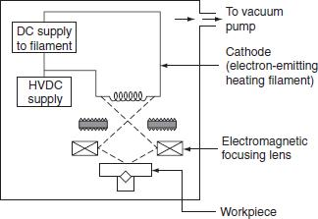

Fig. 5.19 Electron beam welding

Advantages

- Heat input to the electron beam welding can be easily controlled by varying beam current, voltage, the position of filament, etc.

- The electron beam welding can be used to join high temper ture metals such as columbium. o It can be employed for the welding of thick sections, due to high penetration to width ratio.

o It eliminates contamination of both weld zone nd weld etal.

- Narrow electron beam reduces the distortion of workpiece.

Disadvantages

o The pressure b ild p in the vacuum chamber due to the vapor of parent metal causes electrical break down.

- Most of the super alloys, refractory metals, and combinations of dissimilar metals can also be welded.

LASER BEAM WELDING

The word laser means 'light amplification stimulated emission of radiation’. It is the process of joining the metal pieces by focusing a monochromatic light into the extremely concentrated beams, onto the weld zone.

This process is used without shielding gas and without the application of pressure. The laser beam is very intense and unidirectional but can be focused and refracted in the same way as an ordinary light beam. The focus of the laser beam can be controlled by controlling the lenses, mirrors, and the distance to the workpiece. Ablock diagram of the laser beam welding system is shown in Fig. 5.20.

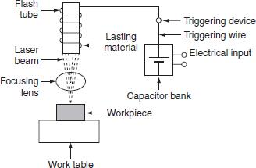

Fig. 5.20 Laser beam welding

In laser beam welding system, flash tube is designed to give th usands of flashes per second. When capacitor bank is triggered, the electrical energy is inje ted into the flash tube through

trigger wire. Flash tube consists of thick xenon ateri l, which produces high power levels for very short period. If the bulb is operated in this anner, it becomes an efficient device, which converts electrical energy to light e ergy. The l ser is then activated.

The laser beam emitting from the flash tube, passing through the focusing lens, where it is pinpointed on the workpiece. The heat so developed by the laser beam melts the work-piece and the weld is comple ed. The wel ing characteristics of the laser are similar to the electron beam.

The laser beam has been used to weld carbon steel, low-alloy steel, aluminum, etc. The metals with relatively high-electrical resistance and the parts of different sizes and mass can be welded.

TYPES OF WELDING ELECTRODES

An electrode is a piece of metal in the form of wire or rod that is either bare or coated uniformly with flux. Electrode carries current for the welding operation. One contact end of the electrode must be clean and is inserted into the electrode holder, an arc is set up at the other end.

The electrodes used for the arc welding are classified as follows (Fig. 5.21).

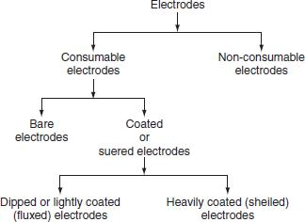

Fig Classification of electrodes

Non-consumable electrodes

Electrodes, which do not consume or fuse during the welding pr ess, are called non-consumable electrodes.

Ex: Electrodes made up of carbon, graphite, or tungsten do not consume during welding.

Consumable electrodes

Electrodes, which are cons med are made up of vario s materials metal to be welded.

uring the welding operation, are consumable electrodes. These epending upon their purpose and the chemical composition of

The consumable electrodes are made in the form of rod having diameter of about 2–8 mm and length of about 200–500 mm. They act as filler rod and are consumed during welding operation.

Bare electrodes

These are the consumable electrodes, which are not coated with any fluxing material. Bare electrodes are in the form of wire. During welding operation, an arc is struck between the workpiece and the electrode wire, then the electrode is melted down into the weld.

When the molten metal electrode and the workpiece are exposed to the atmosphere of oxygen and nitrogen, they form their oxides and nitrides and cause the formation of some non-metallic constituent, which reduces the strength and ductility of the deposited weld. The bare electrodes are usually employed in automatic and semiautomatic welding. With bare electrode, the welding

can be done satisfactorily with DC supply only if the electrode should be connected to the negative terminal of the supply.

Coated electrodes

Depending upon the thickness of flux coating, the coated electrode may classified into:

- lightly coated electrodes and

  - heavily coated electrodes.

For obtaining good weld, the coated electrodes are always preferred.
(i) Lightly coated electrodes
These electrodes are coated with thin layer of coating material up to less than 1 mm. This coating is usually consists of lime mixed with soluble glass which serves as a binder. These electrodes are considered as improvement over bare electrodes.

The main purpose of using the light coating layer on the electr de is to increase the arc stability, so they are also called as stabilizing electrodes. The me hanical strength of the weld increased because slag layer will not formed on the molten weld. F r this reason, lightly coated electrodes may only be used for welding non-essenti l workpie es.

(ii)Heavily coated electrodes
These electrodes have coating la er with heavy thickness. The heavily coated electrodes sometimes referred to as the shielded arc electrodes. The materials commonly used for coating the electrodes are titani m oxi e, ferromanganese, silica, flour, asbestos clay, calcium carbonate, etc. This electrode coa ing helps in improving the quality of weld, as if the coating layer of the electrodes burns in he heat of the arc provides gaseous shield around the arc, which prevents the formation oxides and ni rites.

Advantages
- Arc is stabilized due to the flux compounds of sodium and potassium.

- The weld metal can be protected from the oxidizing action of oxygen and the nitrifying action of

nitrogen due to the gas shielded envelope.

- The impurities present on the surface being welded are fluxed away.

- The electrode coating increases deposition efficiency and weld metal deposition rate through iron powder and ferro alloy addition.

- In case of AC supply arc cools at zero current and there is a tendency of deionizing the arc path. Covering gases keep the arc space ionized.

- The welding operation becomes faster due to the increased melting rate. o The coated electrodes help to deoxidize and refine the weld metal.
The type of electrode used for the welding process depends upon the following factors.

- The nature of the electric supply, either AC or DC.
- The type of the metal to be welded.

- The welding position.

- The polarity of the welding machine.

COMPARISON BETWEEN RESISTANCE AND ARC WELDING

 | Resistance welding |  |  |  | Arc welding
1 |  | The source of supply is AC only. |  |  | The source of supply is either AC (1-φ or 3-φ) or DC.
 | 2 | The head developed is mainly due to the |  |  | The heat developed is mainly due to the striking of arc between
 | flow of contact resistance. |  |  |  | electrodes or an electrode and the workpiece.
3 |  | The temperature attained by the workpiece |  |  | The temperature of the arc is so high, so proper care should be taken
is not so high. |  |  |  |  | during the welding.
 | 4 | External pressure is required. |  |  | No external pressure is required hence the welding equipment is more
 |  |  |  |  | simple and easy to control
5 |  | Filler metal is not required to join two |  |  | Suitable filler electrodes are necessary to get proper welding strength.
metal pieces.
 | 6 | It cannot be used for repair work; it is |  |  | It is not suitable for mass production. It is most suitable for repair
 | suitable for mass production. |  |  |  | works and where more metal is to be deposited.
7 |  | The power consump ion is low. |  |  | The power consumption is high.
 | 8 | The operating power fac or is low. |  |  | The operating power factor is high.
9 |  | Bar, roller, or flat type electrodes are used |  |  | Bare or coated electrodes are used (consumable or non-consumable).
(not consumable).
ELECTRIC WELDING EQUIPMENT

Electric welding accessories required to carry out proper welding operation are:
- Electric welding power sets.

  - Electrode holder to hold the electrodes.

  - Welding cable for connecting electrode and workpiece to the supply.

  - Face screen with colored glass.

  - Chipping hammers to remove slag from molten weld.

- Wire brush to clean the weld.

- Earth clamp and protective clothing.

COMPARISON BETWEEN AC AND DC WELDING

 | AC welding |  |  |  | DC welding
1 |  | Motor generator set or rectifier is required in case of the availability of AC supply |  |  | Only transformer is required.
 | 2 | The cost of the equipment is high. |  |  | The cost of the equipment is cheap.
3 |  | Arc stability is more. |  |  | Arc stability is less.
 | 4 | The heat produced is uniform. |  |  | The heat produced is not uniform.
5 |  | Both bare and coated electrodes can be used. |  |  | Only coated electrodes should be used.
 | 6 | The operating power factor is high. |  |  | The power fact r is l w. So, the capacitors are necessary
 |  |  |  |  | to improve the p wer factor.
7 |  | It is safer since no load voltage is low. |  |  | It is d ngerous sin e no load voltage is high.
 | 8 | The electric energy consumption is 5–10 kWh/kg of |  |  | The electrical energy consumption is 3–4 kWh/kg of
 | deposited metal. |  |  |  | deposited metal
9 |  | Arc blow occurs due to the presence of on-u iform |  |  | Arc blow will not occur due to the uniform magnetic
magnetic field. |  |  |  |  | field.
 | 10 The efficiency is low d e to the rotating parts. |  |  |  | The efficiency is high due to the absence of rotating parts.

CHAPTER 4. Electrolytic Processes: (10 hrs)

4.1 Need of electro-deposition
4.2 Laws of electrolysis, process of electro-deposition - clearing, operation, deposition of metals, polishing and buffing
4.3 Equipment and accessories for electroplating
4.4 Factors affecting electro-deposition
4.5 Principle of galvanizing and its applications
4.6 Principles of anodizing and its applications
4.7 Electroplating of non-conducting materials
4.8 Manufacture of chemicals by electrolytic process
4.9 Power supplies for electroplating

INTRODUCTION
Electrodeposition may refer to:
- Electroplating, a process that uses electric current to reduce dissolved metal cations so that they form a coherent metal coating on an electrode
- Electro-phoretic deposition, a term for a broad range of industrial processes which includes electrocoating, e-coating, cathodic electrodeposition, anodic electro deposition and electrophoretic coating, or electrophoretic painting
- Under potential deposition, a phenomenon of electro deposition of a species (typically reduction of a metal cation to a solid metal) at a potential less negative than the equilibrium (Nernst) potential for the reduction of this metal

  - Need of electro-deposition

Besides protecting metals from corrosion, electroplating can be used for:
- Decorative purposes
- Protecting metals against corrosion
- For electrical conductivity, often found in communication equipment
- For industrial use, such as automobile parts
- To improve premature tarnishing of many metals
- Used in aerospace and aviation
- To increase the thickness of a surface
- To provide a smoother surface finish
Electroplating can be used in many surfaces, transforming them to match other metal pieces or to upgrade their resistance to atmospheric elements.
4.2 Laws of electrolysis, process of electro-deposition - clearing, operation, deposition of metals, polishing and buffing

Terms related to Electrolysis:
Prior to discussing electrolysis let us discuss the basic terms related to electrolysis this will make our discussion of the electrolysis easier:
Electrolyte: Electrolytes are the chemical compound whose atoms are closely bounded but when dissolved in solvents like water ionizes and splits into two ions namely cations and anions. for eg:- NaCl
Cations: A Cation is an ion or charged atom or particle which have fewer electrons than protons or is positively charged and thus attracted to the negative terminal or cathode during electrolysis.
Anions: A Cation is an ion or charged atom or particle which have fewer protons than electrons and is negatively charged thus attracted to the positive terminal or anode during electrolysis.
Electrodes: Electrodes are the conductor of electricity which are used to make contact of the circuit with the electrolytic solution.
Anode: Anode is the positively charged electrode.
Cathode: Cathode is the negatively charged electrode.

Principles of Electrolysis:
When an electrolyte is dissolved into a solution forming an electrolytic solution and the electrodes from an external energy or current source are immersed into the electrolytic solution. Then the Cations of the electrolyte gets attracted to the cathode and anions to the anode. Then the anions loose their electrons to the anode and cations get the deficient electron from the cathode thus creating a flow of electrons through the external energy source thus exchanging the atoms and charges by utilizing the energy from the external energy source. This process is called the Electrolysis.
For example:
When the electrolyte copper sulfate (CuSO₄) is dissolved into water it gives Cation Cu⁺⁺ and Anion SO₄– – which moves freely in the solution. Now if we immerse the positive and negative terminals of a battery into the solution then the Cation Cu⁺⁺ gets attracted to the cathode exchanging the electron from the cathode and Anion SO₄– – gets attracted to the anode exchanging the electrons to the anode. This process causes the deposition of copper at Cathode. And the energy for the whole process is supplied by the Battery through which the current flow.
Electrolysis Of Copper Sulfate

Faraday’s Laws of Electrolysis:
Faraday’s laws are the two laws given by Michael Faraday in 1834 which describes and defines the quantitative relationship between electricity and ions deposited at electrodes. The two laws of Faraday’s Laws of Electrolysis are:

Faraday’s First Law of Electrolysis:
Faraday’s first law of electrolysis states that:
The mass of ions or substances liberated at an electrode during electrolysis is directly proportional to the quantity of electricity transferred to the electrode.
Here,
If, Mass of Ions liberated = m
Quantity of electricity = The total charge used for electrolysis = Q = I * t
I = The current through the electrodes. & t = the time for which the process of electrolysis is run.
Then According to the Faraday’s first law of electrolysis:
or, Where, Z is the constant.
Or,
So, When I = 1 and t=1 m=Z
The “Z” is a constant and is known as the ElectroChemical Equivalent (ECE) of the substance.
The ElectroChemical Equivalent of a substance is the mass of the ions liberated by the passage of one ampere of current through electrodes for one second.
The ECE of a substance is a composite function of the valency and atomic weight of the substance. And it’s value is given by:
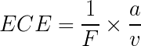
Where, a = Atomic weight of the substance.
v = Valency of the substance
& F = Faraday’s constant , which is the charge required to liberate one gram-equivalent of any substance and is equal to 96485 C mol⁻¹

Faraday’s Second Law of Electrolysis:
Faraday’s Second law states that:
If same amount of electricity is passed through different electrolytes then the mass of substances deposited in the electrodes are proportional to their respective equivalent weight or chemical equivalent.
For example: If same amount of electricity is passed through two electrolytes and in one electrolysis Nickle is deposited in electrode and in another Silver is deposited then the mass of the respective metal deposited is proportional to their ECE. OR,
ECE of Ni / ECE of Ag = Mass of Nickle Deposited / Mass of Silver Deposited

Applications of Electrolysis:
Electrolysis being one of the most important process in electro-chemistry has a lot of applications some of which are listed below:
Electrometallurgy:
Electrometallurgy is the field which is related to the processing of metals with the help of electrolysis. The types of electrometallurgy are:
Electrowinning: Electrowinning is a process of extracting of metals from their ores. For example aluminium can be extracted from bauxite by using electrolysis.
Electrorefining: It is the process of purifying the metals from their impure forms. For example highly pure copper is extracted from blister copper using electrolysis.
Electroplating: Electroplating is the process of deposition of a layer of a metal around another metal. For example metals like iron which are easily corroded by environment and air are electroplated with nickel or chromium with the help of electrolysis.
Electroforming: Electroforming is the process of manufacturing of thin sheets of metals using electroplating or electrolysis.
Production of Chemicals:
Various chemicals are produced with the help of electrolysis. For example chemicals like caustic soda , chlorine , potassium permagnate are produced with the help of electrolysis.

CHAPTER-6 ELECTRIC DRIVE

6.1 Advantages of electric drives

6.2 Characteristics of different mechanical loads

6.3 Types of motors used as electric drive
1. DC series motor

From the construction and operating characteristics of the DC series motor, it is widely suitable for traction purpose. Following features of series motor make it suitable for traction.

- DC series motor is having high-starting torque and having the capability of handling overloads that is essential for traction drives.

  - These motors are having simple and robust construction.

  - The speed control of the series motor is easy by series parallel control.

  - Sparkless commutation is possible, bec use the increase in armature current increases the load torque and decreases the speed so that the emf induced in the coils undergoing commutation.

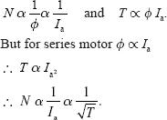
  - Series mo or fl x is proportional to armature current and torque. But armature current is independent of voltage fluctuations. Hence, the motor is unaffected by the variations in supply vol age.

  - We know that:

But the power output of the motor is proportional to the product of torque and speed.
- Motor output

That is motor input drawn from the source is proportional to the square root of the torque. Hence, the series motor is having self-retaining property.

- If more than one motor are to be run in parallel, their speed–torque and current–torque characteristics must not have wide variation, which may result in the unequal wear of driving wheels.

2 DC shunt motor

From the characteristics of DC shunt motor, it is not suitable for traction purpose, due to the following reasons:

- DC shunt motor is a constant speed motor but for traction purpose, the speed of the motor should vary with service conditions.

- In case of DC shunt motor, the power output is independent of speed and is proportional to torque. In case of DC series motor, the power output is proportional

to So that, for a given load torque, the shunt motor has to draw ore power from the supply than series motor.

- For shunt motor, the torque developed is proportional to armature current (T ∝ I_{a}). So for a given load torque motor has to draw more current from the supply.

- The flux developed by shunt motor is proportion l to shunt field current and hence
supply voltage. 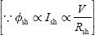. But the torque developed is proportional

to φ_{sh} and I_{a}. Hence, the torque developed by the shunt motor is affected by small variations in s pply voltage.
- If two shunt mo ors are running in parallel, their speed–torque and speed–current characteris ics m st be flat and same. Otherwise, the currents drawn by the motor from the supply mains will be different and cause to unequal sharing of load.

AC series motor

Practically, AC series motor is best suited for the traction purpose due to high-starting torque (Fig. 9.1). When DC series motor is fed from AC supply, it works but not satisfactorily due to some of the following reasons:

- If DC series motor is fed from AC supply, both the field and the armature currents reverse for every half cycle. Hence, unidirectional torque is developed at double frequency.

- Alternating flux developed by the field winding causes excessive eddy current loss, which will cause the heating of the motor. Hence, the operating efficiency of the motor will decrease.

- Field winding inductance will result abnormal voltage drop and low power factor that leads to the poor performance of the motor.

- Induced emf and currents flowing through the armature coils undergoing commutation will cause sparking at the brushes and commutator segments.
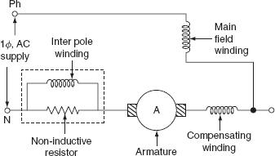

Fig. AC series motor

Hence, some modifications are ecessary for the satisfactory operation of the DC series motor on the AC supply and they are as follows:

- In order to red ce the inductive reactance of the series field, the field winding of AC series motor must be designed for few turns.

  - The decrease in the number of turns of the field winding reduces the load torque, i.e., if field turns decrease, its mmf decrease and then flux, which will increase the speed, and hence the torque will decrease. But in order to maintain constant load torque, it is necessary to increase the armature turns proportionately.

  - If the armature turns increase, the inductive reactance of the armature would increase, which can be neutralized by providing the compensating winding.

  - Magnetic circuit of an AC series motor should be laminated to reduce eddy current losses.

  - Series motor should be operating at low voltage because high voltage low current supply would require large number of turns to produce given flux.

- Motor should be operating at low frequency, because inductive reactance is proportional to the frequency. So, at low frequency, the inductive reactance of the field winding decreases.

The operating characteristics of the AC series motor are similar to the DC series motor. Weight of an AC series motor is one and a half to two times that of a DC series motor. And operating voltage is limited to 300 V. They can be built up to the size of several hundred kW for traction work.

At the time of starting operation, the power factor is low; so that, for a given current, the torque developed by the AC motor is less compared to the DC motor. Thus, the AC series motor is not suitable for suburban services with frequent stops and preferred for main line service where high acceleration is not required.

Three-phase induction motor

The three-phase induction motors are generally preferred for traction purpose due to the following advantages.

- Simple and robust construction.

- Trouble-free operation.

- The absence of commutator.

- Less maintenance.

- Simple and automatic rege eration.

- High efficiency.

Three-phase induc ion motor also suffer from the following drawbacks.

- Low-starting torque.

- High-starting current and complicated speed control system.

- It is difficult to employ three-phase induction motor for a multiple-unit system used for propelling a heavy train.

Three-phase induction motor draws less current when the motor is started at low frequencies. When a three-phase induction motor is used, the cost of overhead distribution system increases and it consists of two overhead conductors and track rail for the third phase to feed power to locomotive, which is a complicated overhead structure and if any person comes in contact with the third rail, it may cause danger to him or her.

This drawback can be overcome by employing kando system. In this system, 1-

- supply from the overhead distribution structure is converted to 3-φ supply by using phase converters and is fed to 3-φinduction motor.

The speed controller of induction motor becomes smooth and easy with the use of thyristorized inverter circuits to get variable frequency supply that can be used to control the speed of three-phase induction motor.

Nowadays, by overcoming the drawbacks of three-phase induction motor, it can be used for traction purpose.

Linear induction motor

It is a special type of induction motor that gives linear motion instead of rotational motion, as in the case of a conventional motor.

In case of linear induction motor, both the movement of field and the movement of the conductors are linear.

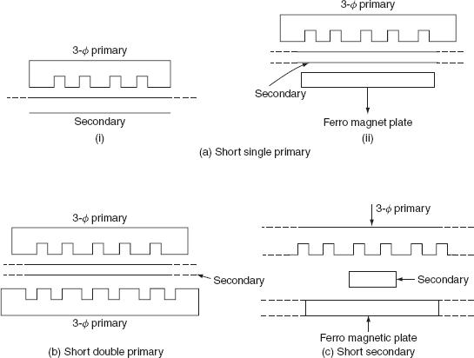
A linear induction motor consists of 3-φ distributed field winding placed in slots, and secondary is nothing but a conducting pl te m de up of either copper or aluminum as shown in Fig. .

Fig Linear induction motor

The field sys em may be either single primary or double primary system. In single primary system, a ferro magnetic plate is placed on the other side of the copper plate; it is necessary to provide low reluctance path for the magnetic flux. When primary is excited by 3-φ AC supply, according to mutual induction, the induced currents are flowing through secondary and ferro magnetic plate. Now, the ferro magnetic plate energized and attracted toward the primary causes to unequal air gap between primary and secondary as shown in Fig. 9.2(a). This drawback can be overcome by double primary system as shown in Fig. 9.2(b). In this system, two primaries are placed on both the sides of secondary, which will be shorter in length compared to the other depending upon the use of the motor.

When the operating distance is large, the length of the primary is made shorter than the secondary because it is not economical to place very large 3-φ primary.

Generally, the short secondary form of system is preferred for limited operating distance, as shown in

When 3-φ primary winding is excited by giving 3-φ AC supply, magnetic field is developed rotating at linear synchronous speed, V_{s}.

The linear synchronous speed is given by:

V_{s} = 2τ f m/s,

where τ is the pole pitch in m and f is the supply frequency in hertzs.

Note: here, the synchronous speed does not depend upon the number of poles but depends upon the pole pitch and the supply frequency.

- Short single primary.

  - Short double primary.

  - Short secondary.

The flux developed by the field winding pulls the rotor same as to the direction of the magnetic field linearly, which will reduce rel tive speed between field and rotor plate. If the speed of the rotor plate is equ l to the magnetic field, then the field would be stationary when viewed from the rotor plate. If rotor plate is rotating at a speed more than linear s chro ous, the direction of a force would be reversed, which causes regenerative braking.

The slip of the linear in uction motor is given by:
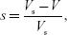

where ‘V ’ is the actual speed of the rotor plate.

The speed–torque (tractive effort) characteristics is shown in Fig. 9.3.

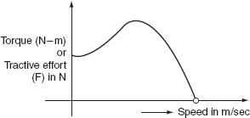

Fig. 9.3 Torque–speed characteristics

Therefore, force or tractive effort is given by:
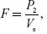

where ‘P₂’ is the actual power supply to the rotor.

Advantages

- Simple in construction.

  - Low initial cost.

  - Maintenance cost is low.

  - Maximum speed is not limited due centrifugal forces.

  - Better power to weight ratio.

Disadvantages

- High cost of providing collector system.

- Poor efficiency and low power factor, due to high currents drawn by the motor because of large air gap.

Applications
Linear induction motor are generally used in:
- High-speed rail traction.

- Trolley cars and metallic belt conveyors.

- Electromagnetic pumps.

Synchronous motor

The synchronous motor is one type of AC motor working based upon the principle of magnetic lacking. It is a constant speed motor running from no-load to full load. The construction of the synchronous motor is similar to the AC generator; armature winding is excited by giving three-phase AC supply and field winding is excited by giving DC supply. The synchronous motor can be operated at leading and lagging power factors by varying field excitation.

The synchronous motor can be widely used various applications because of constant speed from no-load to full load.

- High efficiency. o Low-initial cost.

o Power factor improvement of three-phase AC industrial circuits.

6.4 Electric braking 6.4.1 Plugging 6.4.2 Rheostatic braking 6.4.3 Regenerative braking

BRAKING

If at any time, it is required to stop an electric otor, then the electric supply must be disconnected from its terminals to bring the motor to rest. In this method, even though supply is cut off, the motor continue to rotate for long time due to inertia.

In some cases, there is elay in bri ging the other equipment. So that, it is necessary to bring the motor to rest quickly. The process of bringing the motor to rest within the pre-determined time is known as braking.

A good braking system must have the following features:

- Braking should be fast and reliable.

- The equipment to stop the motor should be in such a way that the kinetic energy of the rotating parts of the motor should be dissipated as soon as the brakes are applied.

Braking applied to bring the motor to rest position is of two types and they are:

- Electric braking.

  - Mechanical braking.

Electric braking

In this process of braking, the kinetic energy of the rotating parts of the motor is converted into electrical energy which in turn is dissipated as heat energy in a resistance or in sometimes, electrical energy is returned to the supply. Here, no energy is dissipated in brake shoes.

Mechanical braking

In this process of braking, the kinetic energy of the rotating parts is dissipated in the form of heat by the brake shoes of the brake lining that rubs on a wheel of vehicle or brake drum.

The advantages of the electric braking over the mechanical braking

- The electric braking is smooth, fast, and reliable.

- Higher speeds can be maintained; this is because the electric braking is quite fast. This

leads to the higher capacity of the system.

- The electric braking is more economical; this is due to ex essive wear on brake blocks

or brake lining that results frequent and costly repl ement in mechanical braking.

o Heat produced in the electric braking is less nd not harmful but heat produced in the mechanical braking will cause the f ilure of brakes.

- In the electric braking, sometimes, it is possible to fed back electric energy during braking period to the supply s stem. This results in saving in the operating cost. This is not possible in case of mecha ical braking.

Disadvantages

In addition to the above advantages, the electric braking suffers from the following disadvantages.

- During the braking period, the traction motor acts generator and electric brakes can almost stop the motor but it cannot hold stationary. Hence, it is necessary to employ
mechanical braking in addition to electric braking.

- Traction motor has to work as a generator during braking period. So that, motor has to

select in such a way that it should have suitable braking characteristics.

- The initial cost of the electric braking equipment is costlier.

TYPES OF ELECTRIC BRAKING

Electric braking can be applied to the traction vehicle, by any one of the following methods, namely:

  - Plugging.

  - Rehostatic braking.

  - Regenerative braking.

Plugging

In this method of braking, the electric motor is reconnected to the supply in such a way that it has to develop a torque in opposite direction to the movement of the rotor. Now, the motor will decelerates until zero speed is zero and then accelerates in opposite direction. Immediately, it is necessary to disconnect the motor from the supply as soon as system comes to rest.

The main disadvantage of this method is that the kinetic energy of the rotating parts of the motor is wasted and an additional amount f energy from the supply is required to develop the torque in reverse direction, i e , in this method, the motor should be connected to the supply during br king. This method can be applied to both DC and AC motors.

Plugging applied to DC motors

Pulling is nothing b t reverse current braking. This method of braking can be applied to both DC sh nt and DC series motors by reversing either the current through armature or the field winding in order to produce the torque in apposite direction, but not both. The connection diagrams for both DC shunt and DC series motors during normal and braking periods are given as follows.

The connection diagram for normal running conditions of both DC shunt and DC series motors are shown in Figs. 9.4 (a) and 9.5 (a). The back emf developed by the motor is equal in magnitude and same as to the direction of terminal or supply voltage. During the braking, the armatures of both shunt and series motors are reversed as shown in Fig. 9.4 (b) and Fig. 9.5 (b). Now, the back emf developed by the motor direction of terminal voltage. A high resistance ‘R’ is connected in series with the armature to limit high-starting current during the braking period.

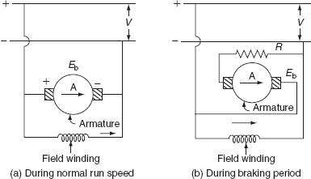

Fig. 9.4 Plugging of DC shunt motor
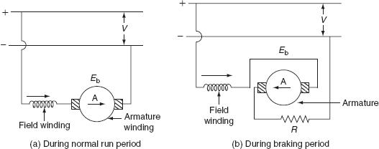

Fig. 9.5 Plugging of DC series motor

Current flowing through the armature during normal run condition:

where V is the supply voltage, E_{b} is the back emf, and R_{a} is the armature resistance.

Current flowing through the armature during braking period:

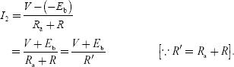

- Electric braking torque, T_{B} ∝ φ I₂.

But we know tha :

Substitute Equation (9.3) in Equation (9.2):
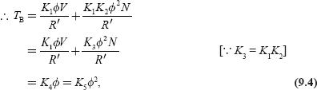

where 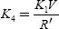 and 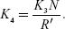.

We know that, in case of series motor flux (φ) developed by the winding is depending the current flowing through it.

In case of shunt motor, the flux remains const nt

Plugging applied to induction motor

During the normal operating condition, the rotating magnetic field developed by the stator and the rotation of rotor are in the same direction. But during the braking period, plugging is applied to an induction motor by reversing any two phases of the three phases of stator winding in order to change the direction of the rotating magnetic field as shown in Fig. 9.6. So that, the rotating magnetic filed and the rotor will be rotating in opposite direction. So that, the relative speed between emf and rotor is nearly twice the synchronous speed N_{s} –(–N_{s}) = 2N_{s}.
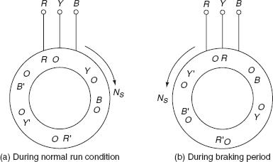

Fig. 9.6 Plugging applied to induction motor
- Slip during the braking period:
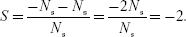

But the voltage induced in the rotor (E₂) is proportional to the slip (S ) × stator voltage (V):
- E₂ ∝ SV.

So, the rotor voltage during the braking period is twice the normal voltage. To avoid the damage of the rotor winding, it should be provided with additional insulation, to withstand the high induced voltage.

The rotation of the magnetic field in the reverse direction produce torque in reverse direction; thereby applying the brakes to the motor. The braking of induction motor can be analyzed by the torque–slip characteristics shown in Fig. 9.7.

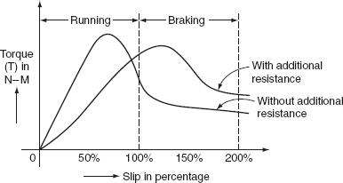

Fig. 9.7 Torque–slip characteristics

Rotor current during the braking period, 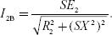.

The characteristic curve for the rotor current and the r t r v ltage with the variation of the slip is shown in Fig. 9.8.
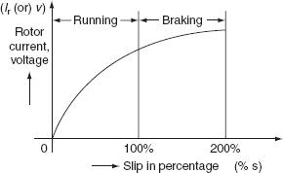

Fig. Rotor current–slip characteristics

Plugging applied to synchronous motor

Normally, the stator winding of the synchronous motor is fed with 3-φ AC supply to produce the rotating magnetic field that induces stator poles. And, the field winding is excited by giving the DC supply thereby inducing the rotor poles. At

any instant, the stator poles gets locked with the rotor poles and the synchronous motor rotating at the synchronous speed. In this method of plugging applied to synchronous motor, simply it is not possible to produce the counter torque during the braking period by interchanging any two of three phases. This is due to the magnetic locking of stator and rotor poles (Fig. 9.9).
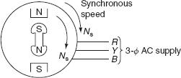

Fig. 9.9 Synchronous motor

In order to develop the counter torque, the rotor of synchronous motor should be provided with damper winding. The EMF induced in the damper winding whenever there is any change, i.e., the reversal of the direction of the stator field. Now, according to Lenz's law, the emf induced in the damper winding opposes the change which producing it. This emf induced in the damper winding produces the circulating current o pro uce the torque in the reverse direction. This torque is known as braking orq e. This braking torque helps to bring the motor to rest.

Rheostatic or dynamic braking

In this method of braking, the electric motor is disconnected from the supply during the braking period and is reconnected across same electrical resistance. But field winding is continuously excited from the supply in the same direction. Thus, during the starts working as generator during the braking period and all the kinetic energy of the rotating parts is converted into electric energy and is dissipated across the external resistance.

One of the main advantages of the rehostatic braking is electrical energy is not drawn by the motor during braking period compared to plugging. The rehostatic braking can be applied to various DC and AC motors.

Rehostatic braking applied to DC motors

The rheostatic braking can be applied to both DC shunt and DC series motors, by disconnecting the armature from the supply and reconnecting it across and external resistance. This is required to dissipate the kinetic energy of all rotating parts thereby brining the motor to rest.

DC shunts motor

Figure 9.10 shows the connection diagram of the DC shunt motor during both normal and braking conditions. In case of DC shunt motor, both armature and field windings are connected across the DC supply, as shown in Fig. 9.10 (a.)
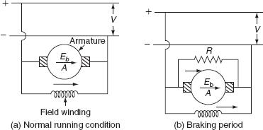

Fig. Rheostatic braking of DC shunt motor

During the braking period, the armature is disconnected from the supply and field winding is continuously excited by the supply in the same direction, as shown in Fig. 9.10 (b). The kinetic energy of all rotating parts is dissipated in the resistor ‘R’ now the machine starts working as generator. Now, braking developed is proportional to the product of the field and the armature currents. But the shunt motor flux remains constant, so the braking torque is proportional to armature current at low-speeds braking torque is less and in order to maintain constant braking torque, the armature is gradually disconnected. Hence, the armature current remains same thereby maintaining the uniform braking torque.

DC series motor

In this braking, which is applied to DC series motor, the armature is disconnected from the supply and is reconnected across an external resistance ‘R’ shown in Fig. 9.11 (a) and (b). But, simply, it is not possible to develop the retarding torque by the DC series motor after connecting armature across the resistance as DC shunt motor.
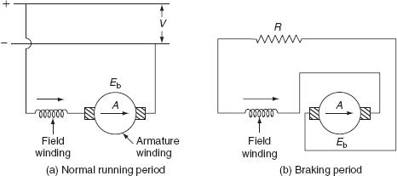

Fig. Rheostatic braking of DC series motor

In case of DC series motor, both the field and armature windings are connected across the resistance after disconnecting the same from the supply; current directions of both the field and armatures are reversed. This results in the production of torque in same direction as before. So, in order to produce the braking torque only the direction of current in the armature has to be reversed. The connection diagram of DC series is shown in Fig. 9.11.

If more than one motor has to be used as in electric traction. All motors can be connected in equalizer connection as shown in Fig. 9.12. In this connection, one machine is excited by the armature current of another machine.

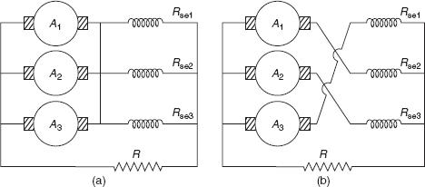

Fig. Equalizer connection

Braking torque

The current flowing through the armature during braking peri d:

where E_{b} is the back emf eveloped, R is the external resistance, and R_{a} is the armature resistance.
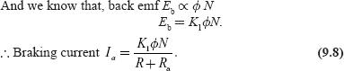

Braking torque, T_{B} ∝ φ I_{a}.

Now, substitute Equation (9.8) in Equation (9.9):
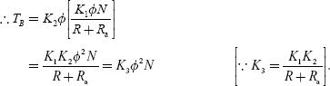

For shunt motor flux is practically constant:

DC series motor

In case of DC series motor, it is not easy to pply regenerative braking as of DC shunt motor. The main reasons of the difficulty of applying regenerative braking to DC series motor are:

- During the braking perio , the motor acts as generator by reversing the direction of current flowing thro gh the armature, but at the same time, the current flowing through the field winding is also reversed; hence, there is no retarding torque. And, a short-circuit condition will set up both back emf and supply voltage will be added together. So that, during the braking period, it is necessary to reverse the terminals of field winding.

  - Some sort of compensating equipment must be incorporated to take care of large change in supply voltage.

On doing some modifications during the braking period, the regenerative braking can be applied to DC series motor. Any one of the following methods is used.

Method-I (French method)

If one or more series motors are running in parallel, during the braking period, the field windings, of all series motors, are connected across the supply in series with

suitable resistance. Thereby converting all series machines in shunt machines as shown in Fig. 9.15.
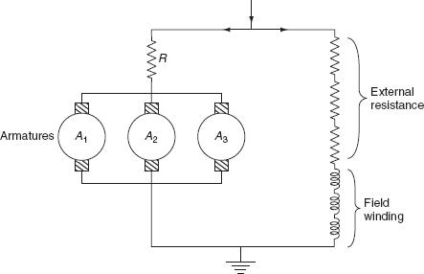

Fig. Regenerative braking of DC series otor

The main advan age of this method is, all armatures are connected in parallel and current supplied o one machine is sufficient to excite the field windings of all the machines, and the energy supplied by remaining all the machines is fed back to the supply system, during the braking period.

Method-II

In this method, the exciter is provided to excite the field windings of the series machine during the regenerative braking period. This is necessary to avoid the dissipation of energy or the loss of power in the external resistance.

Whenever the excitation of field winding is adjusted to increase the rotational emf more than the supply voltage, then the energy is supplied to the supply system. At that time, the field winding of the series machine is connected across an excited being driven by motor operated from an auxiliary supply. Now, during the braking period, the series machine acts as separately excited DC generator which supplies

energy to the main lines. A stabilizing resistance is used to control the braking torque (Figs. 9.16 and 9.17).
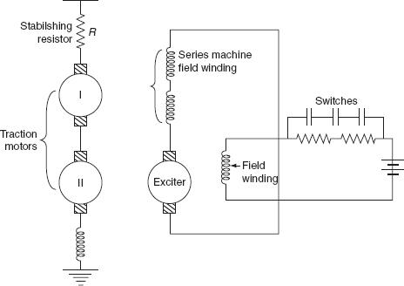

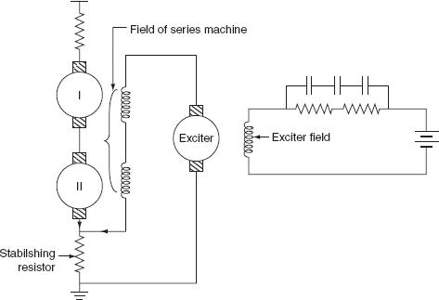
Fig. Regenerative braking

Fig. Regenerative braking

Method-III

In this method, the armature of exciter is connected in series. With the field winding of series machine, this combination is connected across the stabilizing resistance.

Here, the current flowing through stabilizing resistance is the sum of exciter current and regenerated current by the series machines.

During the braking period, the regenerated current increases the voltage drop across the stabilizing resistance, which will reduce the voltage across the armature circuit and cause the reduction of the exciter current of the series machine field winding. Hence, the traction motors operating as series generators.

Regenerative braking applied to 3-φ induction motor

Regenerative braking is applied to the induction motor by increasing its speed above the synchronous speed. Now, the induction mot r acting as an induction generator that feeds power to the main line. The torque slip characteristics of the induction motors are shown in Fig. 9.18.
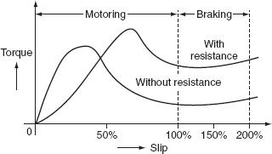

Fig. Torque vs slip characteristics

The main advantage of the induction motor is during the braking period; no need of placing external resistance in the rotor circuit. The speed during the braking remains almost constant and independent of the gradient and the weight of the train.

This regenerative braking applied to an induction motor can save 20% of the total energy leads the reduction of operating cost.

Regenerative braking applied to AC series motors

It is not simple way to apply regenerative braking to an AC series motor. In this method, the armature of traction motor is connected to the top changing transformer through iron cored reactors RE₁ andRE₂ and commutating pole winding ‘C’.

An auxiliary transformer is provided to excite the field winding of the traction motor. Let us assume ‘V ’ be the voltage of tap-changing transfor er and I_{f} is the field current of traction motor. Due to the presence of react r, I_{f} lags V by an angle 90° of traction motor is phase with exciting current as sh wn in Fig. 9.19.
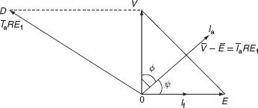

Fig. Phasor diagram

From the phasor diagram, the vector difference of and gives voltage across

iron-cored reactor RE₁. Now, the armature current I_{a} lags 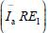 by 90°. And, the braking torque developed the series machine will be proportional to I_{a} cosφ. And, the power returned to the supply is also proportional I_{a} cosφ. So that, proper phase angle must be obtained for efficient braking effect arise in the regenerative braking applied to an AC series motor are:

- During the regenerative braking, the braking torque is proportional to the operating

power factor. In order to operate the series motor at high power factor field, winding must be excited separately from other auxiliary devices.

- Proper phase-shifting device must be incorporated to ensure correct phase angle.

To overcome the difficulty stated above, a special arrangement is adopted that is known as Behn Eschenburg method of regenerative braking.

The circuit diagram for applying regenerative braking to an AC series motor is shown in Fig. 9.20.
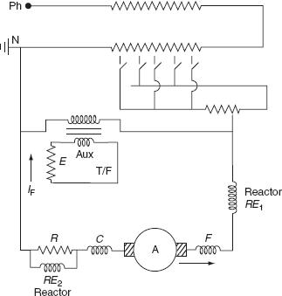

Fig. 9.20 Regenerative braking of AC series motor
Advantages of regenerative braking

- In regenerative breaking, a part of the energy stored by the rotating parts is converted into the electrical energy and is fed back to the supply. This will lead to the minimum consumption of energy, thereby saving the operating cost.

- High breaking retardation can be obtained during regenerative breaking.

3. Time taken to bring the vehicle to rest is less compared to the ther breakings; so that, the running time of the vehicle is considerably redu ed

- The wear on the brake shoes and tyre is reduced, whi h in reases the life of brake shoe and tyre.

Disadvantages

In addition to the above advantages, this method suffers from the following disadvantages.

- In addition o he regenerative breaking, to bring the vehicle to standstill, mechanical breaking is to be employed.

- In case of DC traction, additional equipment is to be employed for regenerative breaking, which increases the cost and sometimes, substation are equipped with mercury arc rectifiers to convert AC to DC supply.

- The electrical energy returned to the supply will cause the operation of substations complicated.

6.5 General idea about the methods of power transfer by direct coupling by using devices like belt drive, gears, chain drives etc.

6.6 Examples of selection of motors for different types of domestic loads

6.7 Selection of drive for applications such as general workshop, textile mill, paper mill, steel mill, printing press, crane and lift etc. Application of flywheel.

6.8 Specifications of commonly used motors e.g. squirrel cage motors, slip ring induction motors, AC series motors, Fractional kilo Watt(FKW) motors

6.9 Selection of motors for Domestic Appliances

CHAPTER-7 ELECTRIC TRACTION

INTRODUCTION

The system that causes the propulsion of a vehicle in which that driving force or tractive force is obtained from various devices such as electric motors, steam engine drives, diesel engine dives, etc. is known as traction system.
Traction system may be broadly classified into two types. They are electric-traction systems, which use electrical energy, and non-electric traction system, which does not use electrical energy for the propulsion of vehicle.

7.3 Different accessories for track electrification; such as overhead catenaries wire, conductor rail system, current collector-pantograph
7.4 Factors affecting scheduled speed
7.5 Electrical block diagram of an electric locomotive with description of various equipment and accessories used.
7.6 Types of motors used for electric traction
7.7 Power supply arrangements
7.8 Starting and braking of electric locomotives
7.9 Introduction to EMU and metro railways
7.10 Train Lighting Scheme Note: Students should be taken for visits to nearest electrified railway track and railway station to study the electric traction system.

Requirements of ideal traction system

Normally, no single traction system fulfills the requirements f ideal traction system, why because each traction system has its merits and suffers from its own demerits, in the fields of applications.

The requirements of ideal traction systems are:

- Ideal traction system should have the capability of developing high tractive effort in

order to have rapid acceleration.

- The speed control of the traction motors should be easy.

- Vehicles should be able to run on any route, without interruption.

- Equipment required for traction system should be minimum with high efficiency. o It must be free from smoke, ash, dirt, etc.

o Regenerative braking should be possible and braking should be in such a way to cause minimum wear on the break shoe.

o Locomotive should be self-contained and it must be capable of withstanding overloads. o Interference to the communication lines should be eliminated while the locomotive

running along the track.

7.1 Advantages of electric traction over other types of traction.

Advantages and Disadvantages of Electric Traction

Electric traction system has many advantages compared to non-electric traction systems. The following are the advantages of electric traction:

- Electric traction system is more clean and easy to handle.

- No need of storage of coal and water that in turn reduces the maintenance cost as well

as the saving of high-grade coal.

- Electric energy drawn from the supply distribution system is sufficient to maintain the common necessities of locomotives such as fans and lights; therefore, there is no need

of providing additional generators.

- The maintenance and running costs are comparatively low. o The speed control of the electric motor is easy.

o Regenerative braking is possible so that the energy can be fed back to the supply system during the braking period.

o In electric traction system, in addition to the mechanical braking, electrical braking can also be used that reduces the wear on the brake shoes, wheels, etc.

o Electrically operated vehicles can withstand for overloads, as the system is capable of drawing more energy from the system.

In addition to the above advantages, the electric traction system suffers from the following drawbacks:

- Electric traction system involves high erection cost of power system.

o Interference causes to the communication lines due to the overhead distribution networks.

- The failure of power supply brings whole traction system to stand still.

- In an electric traction system, the electrically operated vehicles have to move only on

o

the electrified routes.

Additional equipment should be needed for the provision of regenerative braking, it

will increase the overall cost of installation.

7.2 Different systems of electric traction, DC and AC systems, diesel electric system, types of services – urban, sub-urban, and main line and their speed-time curves

REVIEW OF EXISTING ELECTRIC TRACTION SYSTEM IN INDIA

In olden days, first traction system was introduced by Britain in 1890 (600-V DC track). Electrification system was employed for the first traction vehicle. This traction system was introduced in India in the year 1925 and the first traction system employed in India was from Bombay VT to Igatpuri and Pune, with 1,500-V DC supply. This DC supply can be obtained for traction from substations equipped with rotary converters. Development in the rectifiers leads to the replacement of rotary converters by mercury arc rectifiers. But nowadays further development in the technology of semiconductors, these mercury arc valves are replaced by solid-state semiconductors devices due to fast traction system was introduced on 3,000-V DC. Further development in research on traction system by French international railways was suggested that, based on relative merits and

demerits, it is advantageous to prefer to AC rather than DC both financially and operationally.

Thus, Indian railways was introduced on 52-kV, 50-Hz single-phase AC system in 1957; this system of track electrification leads to the reduction of the cost of overhead, locomotive equipment, etc. Various systems employed for track electrification are shown in Table .

Table Track electrification systems
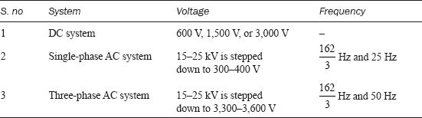

SYSTEM OF TRACTION

Traction system is normally classified into two types based on the type of energy given as input to drive the s stem a d they are:

- Non-electric Traction system

Traction system develops the necessary propelling torque, which do not involve the use of electrical energy at any stage to drive the traction vehicle known as electric traction system.

Ex: Direct steam engine drive and direct internal combustion engine drive.

- Electric traction system

Traction system develops the necessary propelling torque, which involves the use of electrical energy at any stage to drive the traction vehicle, known as electric traction system.

Based upon the type of sources used to feed electric supply for traction system, electric traction may be classified into two groups:

- Self-contained locomotives.
- Electric vehicle fed from the distribution networks.

Self-contained locomotives

In this type, the locomotives or vehicles themselves having a capability of generating electrical energy for traction purpose. Examples for such type of locomotives are:

- Steam electric drive

In steam electric locomotives, the steam turbine is employed for driving a generator used to feed the electric motors. Such types of locomotives are not generally used for traction because of some mechanical difficulties and maintenance problems.

2. Diesel electric trains

A few locomotives employing diesel engine coupled to DC generator used
to feed the electric motors producing necessary propelling torque. Diesel
engine is a variable high-speed type that feeds the self- or separately
excited DC generator. The excitation for generator can be supplied from
any auxiliary devices and battery.
Generally, this type of traction system is suggested in the areas where

coal and steam tractions are not available. The advantages and
disadvantages of the diesel engine drive re given below:

Advantages

o As these are no overhead distribution system, initial cost is low.

o Easy speed control is possible.

o Power loss in speed control is very low

o Time taken to bring the locomotive into service is less.

o In this system, high acceleration and braking retardation can be obtained compared to

steam locomotives.

- The overall efficiency is high compared to steam locomotives.

Disadvantages

- The overloading capability of the diesel engine is less. o The running and maintenance costs are high.

o The regenerative braking cannot be employed for the diesel engine drives.

Petrol electric traction

This system of traction is used in road vehicles such as heavy lorries and buses. These vehicles are capable of handling overloads. At the same time, this system

provides fine and smooth control so that they can run along roads without any jerking.

Battery drives

In this drive, the locomotive consists of batteries used to supply power to DC motors employed for driving the vehicle. This type of drives can be preferred for frequently operated services such as local delivery goods traction in industrial works and mines, etc. This is due to the unreliability of supply source to feed the electric motors.

Electric vehicles fed from distribution network

Vehicles in electrical traction system that receives power from over head distribution network fed or substations with suitable spacing. Based on the available supply, these groups of vehicles are further subdivided into:

- System operating with DC supply. Ex: tramways, trolley buses, and railways.

- System operating with AC supply. Ex: railways.

Systems operating with DC supply

In case if the available supply is DC, then the necessary propelling power can be obtained for the vehicles from DC system such as tram ways, trolley buses, and railways.

Tramways: Tramways are similar to the ordinary buses and cars but only the difference is they are able to run only along the track. Operating power supply for the tramways is 500-V DC tramways are fed from single overhead conductor acts as positive polarity that is fed at suitable points from either power station or substations and the track rail acts as return conductor.

The equipment used in tramways is similar to that used in railways but with small output not more than 40–50 kW. Usually, the tramways are provided with two driving axels to control the speed of the vehicles from either ends. The main drawback of tramways is they have to run along the guided routes only. Rheostatic and mechanical braking can be applied to tramways. Mechanical brakes can be applied at low speeds for providing better saturation where electric braking is ineffective, during the normal service. The erection and maintenance costs of tramways are high since the cost of overhead distribution structure is costlier and sometimes, it may cause a source of danger to other road users.

Trolley buses: The main drawback of tramways is, running along the track is avoided in case of trolley buses. These are electrically operated vehicles, and are fed usually 600-V DC from two overhead conductors, by means of two collectors. Even though overhead distribution structure is costlier, the trolley buses are advantageous because, they eliminate the necessity of track in the roadways.

In case of trolley buses, rheostatic braking is employed, due to high adhesion between roads and rubber types. A DC compound motor is employed in trolley buses.

SYSTEM OF TRACK ELECTRIFICATION

Now a days, based on the available supply, the track electrification system are categorized into.

- DC system.

- Single-phase AC system.

- Three-phase AC system.

- Composite system.

1 DC system

In this system of traction, the electric motors employed for getting necessary propelling torque should be selected in such a way that they should be able to operate on DC supply. Examples for such vehicles operating based on DC system are tramways and trolley buses. Usually, DC series motors are preferred for tramways and trolley buses even though DC compound motors are available where regenerative braking is desired. The operating voltages of vehicles for DC track electrification system are 600, 750, 1,500, and 3,000 V. Direct current at 600–750 V is universally employed for tramways in the urban areas and for many suburban and main line railways, 1,500–3,000 V is used. In some cases, DC supply for traction motor can be obtained from substations equipped with rotary converters to convert AC power to DC. These substations receive AC power from 3-φ high-voltage line or single-phase overhead distribution network. The operating voltage for traction purpose can be justified by the spacing between stations and the type of traction motors available. Theses substations are usually automatic and remote controlled and they are so costlier since they involve rotary converting equipment. The DC system is preferred for suburban services and road transport where stops are frequent and distance between the stops is small.
2 Single-phase AC system

In this system of track electrification, usually AC series motors are used for getting the necessary propelling power. The distribution network employed for such traction systems is normally 15–25 kV at reduced frequency of 163⅔ Hz or 25 Hz. The main reason of operating at reduced frequencies is AC series motors that are more efficient and show better performance at low frequency. These high voltages are stepped down to suitable low voltage of 300–400 V by means of step-down transformer. Low frequency can be obtained from normal supply frequency with the help of frequency converter. Low-frequency operation of overhead transmission line reduces the line reactance and hence the voltage drops directly and single-phase AC system is mainly preferred for main line services where the cost of overhead structure is not much importance moreover rapid acceleration and retardation is not required for suburban services.

3 Three-phase AC system

In this system of track electrification, 3-φ induction motors are employed for getting the necessary propelling power. The operating voltage of induction motors

is normally 3,000–3,600-V AC at either norm l supply frequency or 16⅔-Hz frequency.

Usually 3-φ induction motors are preferable because they have simple and robust construction, high operating efficiency, provision of regenerative braking without placing any additional equipment, and better performance at both normal and seduced frequencies. In addition to the above advantages, the induction motors suffer from some drawbacks; they are low-starting torque, high-starting current, and the absence of speed control. The main disadvantage of such track electrification system is high cost of overhead distribution structure. This distribution system consists of two overhead wires and track rail for the third phase and receives power either directly from the generating station or through transformer substation.

Three-phase AC system is mainly adopted for the services where the output power required is high and regeneration of electrical energy is possible.

4 Composite system

As the above track electrification system have their own merits and demerits, 1-

- AC system is preferable in the view of distribution cost and distribution voltage
can be stepped up to high voltage with the use of transformers, which reduces the transmission losses. Whereas in DC system, DC series motors have most desirable features and for 3-φ system, 3-φ induction motor has the advantage of automatic regenerative braking. So, it is necessary to combine the advantages of the DC/AC and 3-φ/1-φ systems. The above cause leads to the evolution of composite system.

Composite systems are of two types.

- Single-phase to DC system.

- Single-phase to three-phase system or kando system.

Single-phase to DC system

In this system, the advantages of both 1-φ and DC systems are combined to get high voltage for distribution in order to reduce the losses that can be achieved with 1-φ distribution networks, and DC series motor is employed for producing the necessary propelling torque. Finally, 1-φ AC distribution network results minimum cost with high transmission efficiency and DC series m t r is ideally suited for traction purpose. Normal operating voltage employed f distribution is 25 kV at normal frequency of 50 Hz. This track electrification is employed in India.

Single-phase to 3-φ system or kundo system

In this system, 1-φ AC system is preferred for distribution network. Since single-phase overhead distribution s stem is cheap and 3-φ induction motors are employed as traction motor because of their simple, robust construction, and the provision of automatic regenerative braking.

The voltage used for the distribution network is about 15–25 kV at 50 Hz. This 1-φ supply is converted to 3-φ supply through the help of the phase converters and high voltage is stepped down transformers to feed the 3-φ induction motors. Frequency converters are also employed to get high-starting torque and to achieve better speed control with the variable supply frequency.

SPECIAL FEATURES OF TRACTION MOTORS

The general features of the electric motors used for traction purpose are:

- Mechanical features.

- Electrical features.
Mechanical features

- A traction motor must be mechanically strong and robust and it should be capable of withstanding severe mechanical vibrations.

- The traction motor should be completely enclosed type when placed beneath the locomotive to protect against dirt, dust, mud, etc.

- In overall dimensions, the traction motor must have small diameter, to arrange easily beneath the motor coach.

- A traction motor must have minimum weight so the weight of locomotive will decrease. Hence, the load carrying capability of the motor will increase.

Electrical features

High-starting torque
A traction motor must have high-starting torque, which is required to start the motor on load during the starting conditions in urban and suburban services.

Speed control
The speed control of the traction motor must be simple and easy. This is necessary for the frequent starting and stopping of the motor in traction purpose.

Dynamic regenerative braking

Traction motors should be able to provide easy simple rheostatic and regenerative braking subjected to higher voltages so that system must have the capability of withstanding voltage fluctuations.

Temperature

The traction motor should have the capability of withstanding high temperatures during transient conditions.

Overload capacity

The traction motor should have the capability of handling excessive overloads.
Parallel running

In traction work, more number of motors need to run in parallel to carry more load. Therefore, the traction motor should have such speed–torque and current–torque characteristics and those motors may share the total load almost equally.

Commutation

Traction motor should have the feature of better commutation, to avoid the sparking at the brushes and commutator segments.

TRACTION MOTORS

No single motor can have all the electrical operating features required for traction.

In earlier days, DC motor is suited for traction because of the high-starting torque and having the capability of handling overloads. In addition to the above characteristics, the speed control of the DC motor is very complicated through semiconductor switches. So that, the motor must be designed for high base speed initially by reducing the number of turns in the field winding. But this will decrease the torque developed per ampere at the time of staring. And regenerative braking is also complicated in DC series motor; so that, the separately excited motors can be preferred over the series motor because their speed control is possible through semi-controlled converters. And also dynamic and regenerative braking in separately excited DC motor is simple and efficient.

DC compound motors are also preferred for traction applications since it is having advantageous features than series and separately excited motors.

But nowadays squirrel cage induction and synchronous motors are widely used for traction because of the availability of reliable variable frequency semiconductor inverters.

The squirrel cage induction motor has several advantages over the DC motors.
They are:

- Robust construction.

  - Highly reliable.

  - Low maintenance and low cost.

  - High efficiency.

Synchronous motor features lie in between the squirrel cage induction motor and the DC motor. The main advantages of the synchronous motor over the squirrel cage induction motor are:

- The synchronous motors can be operated at leading power by varying the field excitation.

  - Load commutated thyristor inverter is used in synchronous motors as compared to forced commutation thyristor inverter in squirrel cage induction motors.

Even though such forced commutation reduces the weight and volume of induction motor, the synchronous motor is less expensive.

TRACTION MOTOR CONTROL

Normally, at the time of starting, the excessive current drawn by the electric motor from the main supply causes to the effects. So that, it is necessary to reduce the current drawn by the traction motor for its smooth control such as:
- To achieve smooth acceleration without any jerking and sudden shocks.
- To prevent damage to coupling.

- To achieve various speed depending upon the type of services.

Control of DC motors

At the time of starting, excessive current is drawn by the traction motor when rated voltage is applied across its terminals. During the starting period, the current drawn by the motor is limited to its rated current. This can be achieved by placing a resistance in series with the armature winding. This is known as starting resistance; it will be cut off during the normal running period thereby applying rated voltage across its armature terminals. By the resistance of stating resistor, there is considerable loss of energy takes place in it.
- At the time of switching on, the back emf developed by the motor E_{b} = 0.

where V_{s} is the voltage drop across st rting resistance and I_{a}R_{a} is the voltage drop in armature.

During the running con itio :

At the end of accelerating period, the total starting resistance will be cut off from the armature then:

Various drops during staring and running with armature resistance.

2. Various drops during staring and running with negligible armature resistance.

When armature resistance is neglected R_{a} = 0 and ‘t’ is the time in seconds for starting, then total energy supplied is, V_{a}I_{a}t watts-sec and the energy wasted in the starting resistance at the time of starting can be calculated from Fig. 9.21(b) as:
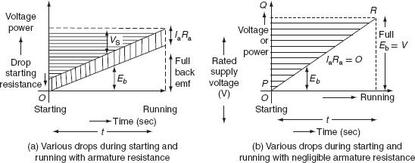

FigTraction control of DC motor

That is whatever the electrical energy supplied to the motor, half of the energy is wasted during the starting resistor.
- The efficiency of the traction motor at time of starting, η_{start} = 50%.

AUXILIARY EQUIPMENT

A traction system comprises of the following auxiliary equipment in addition to the main traction motors required to be arranged in the locomotive are discussed below.

Motor–generator set

Motor–generator set consists of a series motor and shunt generator. It is mainly used for lighting, control system, and the other power ir uits of low voltages in the range 10–100 V. The voltage of generator is effectively controlled by automatic voltage regulator.

Battery

It is very impor ant o se the battery as a source of energy for pantograph, to run auxiliary compressor, to operate air blast circuit breaker, etc. The capacity of battery used in the locomotive is depending on the vehicle. Normally, the battery may be charged by a separate rectifier.

Rectifier unit

If the track electrification system is AC motors and available traction motors are
DC motors, then rectifiers are to be equipped with the traction motors to convert
AC supply to DC to feed the DC traction motors.
Transformer or autotransformer

Depending on the track electrification system employed, the locomotive should be equipped with tap-changing transformers to step-down high voltages from the distribution network to the feed low-voltage traction motors.

Driving axles and gear arrangements

All the driving motors are connected to the driving axle through a gear arrangement, with ratios of 4:1 or 6:1.

TRANSMISSION OF DRIVE

Drive is a system used to create the movement of electric train. The electric locomotives are specially designed to have springs between the driving axles and the main body. This arrangement of springs reduces the da age not only to the track wings but also to the hammer blows.

The power developed by the armature of the tr ction m t rs must be transferred to the driving axels through pinion and gear drive There are several methods by which power developed by the armature can be tr nsferred to the driving wheel.

Gearless drive

Gearless drives are of two t pes.

Direct drive

It is a simple drive. The armatures of the electric motors are mounted directly on the driving axle with the field attached to the frame of locomotive. In this system, the poles of electric motors should be flat so that the armature can be able to move freely without affecting of the operation. Here, the size of the armatures of the traction motor is limited by the diameter of the driving wheels. The arrangement of direct drive is shown in fig,

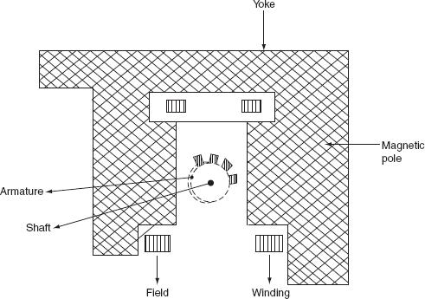

Fig. Direct drive

Direct quill drive

Quill is nothing but a hallow shaft. Driving axle is surrounded by the hollow shaft attached by springs. The armature of the motor is mounted on a quill. The speed and the size of he armature are limited by the diameter of the driving wheels.

Geared drive

In this drive, the armature of the traction motor is attached to the driving wheel through the gear wheel system. Now, the power developed by the armature is transferred to the driving wheel through the gear system. Here, gear drive is necessary to reduce the size of the motor for given output at high speeds (Fig. 9.33). The gear ratio of the system is usually 3–5:1.

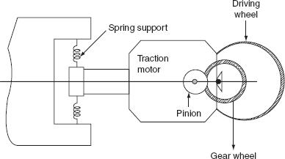

Fig. Geared drive

Brown–Boveri individual drive

In this drive, a special link is provided between the gear wheel and driving wheel, which provides more flexibility of the system.

AUXILIARY EQUIPMENT

A traction system comprises of the following auxiliary equipment in addition to the main traction motors required to be arranged in the locomotive are discussed below.

Motor–generator set

Motor–generator set consists of a series motor and shunt generator. It is mainly used for lighting, control system, and the other power ir uits of low voltages in the range 10–100 V. The voltage of generator is effectively controlled by automatic voltage regulator.

Battery

It is very impor ant o se the battery as a source of energy for pantograph, to run auxiliary compressor, to operate air blast circuit breaker, etc. The capacity of battery used in the locomotive is depending on the vehicle. Normally, the battery may be charged by a separate rectifier.

Rectifier unit

If the track electrification system is AC motors and available traction motors are
DC motors, then rectifiers are to be equipped with the traction motors to convert
AC supply to DC to feed the DC traction motors.
Transformer or autotransformer

Depending on the track electrification system employed, the locomotive should be equipped with tap-changing transformers to step-down high voltages from the distribution network to the feed low-voltage traction motors.

Driving axles and gear arrangements

All the driving motors are connected to the driving axle through a gear arrangement, with ratios of 4:1 or 6:1.

TYPES OF SERVICES

There are mainly three types of passenger services, by which the type of traction system has to be selected, namely:

- Main line service.

- Urban or city service.

- Suburban service.

Main line services

In the main line service, the distance between two stops is usually more than 10 km. High balancing speeds should be required. Acceleration and retardation are not so important.

Urban service

In the urban service, the distance between two stops is very less and it is less than 1 km. It requires high average speed for frequent starting and stopping.

Suburban service

In the suburban service, the distance between two stations is between 1 and 8 km. This service requires rapid acceleration and retardation as frequent starting and stopping is required.

SPEED–TIME AND SPEED–DISTANCE CURVES FOR DIFFERENT SERVICES

The curve that shows the instantaneous speed of train in kmph along the ordinate and time in seconds along the abscissa is known as ‘speed–time’ curve.

The curve that shows the distance between two stations in km along the ordinate and time in seconds along the abscissa is known as ‘speed–distance’ curve.

The area under the speed–time curve gives the distance travelled during, given time internal and slope at any point on the curve toward abscissa gives the acceleration and retardation at the instance, out of the two speed–ti e curve is more important.

Speed–time curve for main line service

Typical speed–time curve of a train running on main line service is shown in Fig.
10.1. It mainly consists of the following time periods:

- Constant accelerating period.

  - Acceleration on speed curve.

  - Free-running period.

  - Coasting period.

  - Braking period.

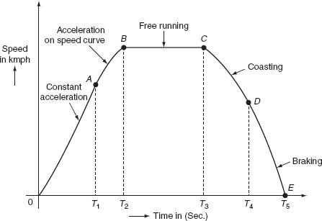

Fig. 10.1 Speed–time curve for mainline service

Constant acceler tion

During this period, the traction motor ccelerate from rest. The curve ‘OA’

represents the constant accelerati g period. During the instant 0 to T₁, the current is maintained approximately co sta t and the voltage across the motor is gradually increased by cutting out the starting resistance slowly moving from one notch to the other. Thus, c rrent taken by the motor and the tractive efforts are practically constant and therefore acceleration remains constant during this period. Hence, this period is also called as notch up accelerating period or rehostatic accelerating period. Typical value of acceleration lies between 0.5 and 1 kmph. Acceleration is denoted with the symbol ‘α’.

Acceleration on speed-curve

During the running period from T₁ to T₂, the voltage across the motor remains constant and the current starts decreasing, this is because cut out at the instant ‘T₁’.

According to the characteristics of motor, its speed increases with the decrease in the current and finally the current taken by the motor remains constant. But, at the same time, even though train accelerates, the acceleration decreases with the increase in speed. Finally, the acceleration reaches to zero for certain speed, at which the tractive effort excreted by the motor is exactly equals to the train resistance. This is also known as decreasing accelerating period. This period is shown by the curve ‘AB’.

Free-running or constant-speed period

The train runs freely during the period T₂ to T₃ at the speed attained by the train at the instant ‘T₂’. During this speed, the motor draws constant power from the supply lines. This period is shown by the curve BC.

Coasting period

This period is from T₃ to T₄, i.e., from C to D. At the instant ‘T₃’ power supply to the traction, the motor will be cut off and the speed falls on account of friction, windage resistance, etc. During this period, the train runs due to the momentum attained at that particular instant. The rate of the decrease of the speed during coasting period is known as coasting retardation. Usually, it is denoted with the symbol ‘β_{c}’.

Braking period

Braking period is from T₄ to T₅, i.e., from D to E. At the end of the coasting period,

i.e., at ‘T4’ brakes are applied to bri g the train to rest. During this period, the speed of the train decreases rapidly a d fi lly reduces to zero.

In main line service, the free-running period will be more, the starting and braking periods are very negligible, since the distance between the stops for the main line service is more than 10 km.

Speed–time curve for suburban service

In suburban service, the distance between two adjacent stops for electric train is lying between 1 and 8 km. In this service, the distance between stops is more than the urban service and smaller than the main line service. The typical speed–time curve for suburban service is shown in Fig. 10.2.

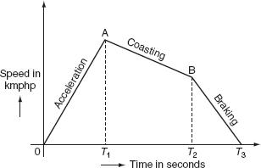

Fig. 10.2 Typical speed–time curve for suburban service

The speed–time curve for urban service consists of three distinct periods. They are:

1. | Acceleration.
2. | Coasting.
3. | Retardation.
For this service, there is no free-ru |  | ing period. The coasting period is
comparatively longer since the dista |  | ce between two stops is more. Braking or

retardation period is comparatively small. It requires relatively high values of acceleration and re ardation. Typical acceleration and retardation values are lying between 1.5 and 4 kmphp and 3 and 4 kmphp, respectively.

Speed–time curve for urban or city service

The speed–time curve urban or city service is almost similar to suburban service and is shown in Fig. 10.3.
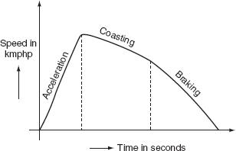

Fig. 10.3 Typical speed–time curve for urban service

In this service also, there is no free-running period. The distance between two stop is less about 1 km. Hence, relatively short coasting and l nger braking period is required. The relative values of acceleration and retardati n are high to achieve moderately high average between the stops. Here, the small coasting period is included to save the energy consumption. The cceleration for the urban service lies between 1.6 and 4 kmphp. The co sting retardation is about 0.15 kmphp and the braking retardation is lying between 3 and 5 kmphp. Some typical values of various services are shown in Table. 10.1.

Table 10.1 Types of services
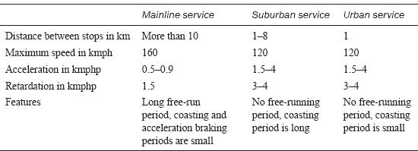

SOME DEFINITIONS

Crest speed

The maximum speed attained by the train during run is known as crest speed. It is denoted with ‘V_{m}’.

Average speed

It is the mean of the speeds attained by the train from start to stop, i.e., it is defined as the ratio of the distance covered by the train between two stops to the total time of rum. It is denoted with ‘V_{a}’.
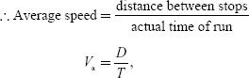

where V_{a} is the average speed of tr in in k ph, D is the distance between stops in km, and T is the actual time of run in hours.

Schedule speed

The ratio of the dis ance covered between two stops to the total time of the run including the time for stop is known as schedule speed. It is denoted with the symbol ‘V_{s}’.
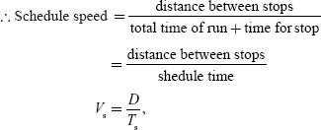

where T_{s} is the schedule time in hours.

Schedule time

It is defined as the sum of time required for actual run and the time required for stop.

i.e., T_{s} = T_{run} + T_{stop}.

FACTORS AFFECTING THE SCHEDULE SPEED OF A TRAIN

The factors that affect the schedule speed of a train are:

- Crest speed.

- The duration of stops.

- The distance between the stops.

- Acceleration.

- Braking retardation.

Crest speed

It is the maximum speed of train, which affects the schedule speed as for fixed acceleration, retardation, and coastat distance between the stops. If the crest speed increases, the actual running time of train decreases. For the low crest speed of train it running so, the high crest speed of train will increases its schedule speed.

Duration of stops

If the duration of stops is more, then the running time of train will be less; so that, this leads to the low schedule speed.

Thus, for high schedule speed, its duration of stops must be low.

Distance between the stops

If the distance between the stops is more, then the running time of the train is less; hence, the schedule speed of train will be more.
Acceleration

If the acceleration of train increases, then the running time of the train decreases provided the distance between stops and crest speed is maintained as constant. Thus, the increase in acceleration will increase the schedule speed.

Braking retardation

High breaking retardation leads to the reduction of running time of train. These will cause high schedule speed provided the distance between the stops is small.

